
FATIMA JINNAH WOMEN UNIVERSITY
RAWALPINDI
Department Of Software Engineering

Cloud Computing Lab
Saira Ejaz [2023-BSE-057]
Section: 5-B
LAB NO 12

Lab 12 – Terraform Provisioners, Modules & Nginx Reverse Proxy/Load Balancer
Task 0 Lab Setup (Codespace & GH CLI)
- task0_codespace_create_and_list. Png
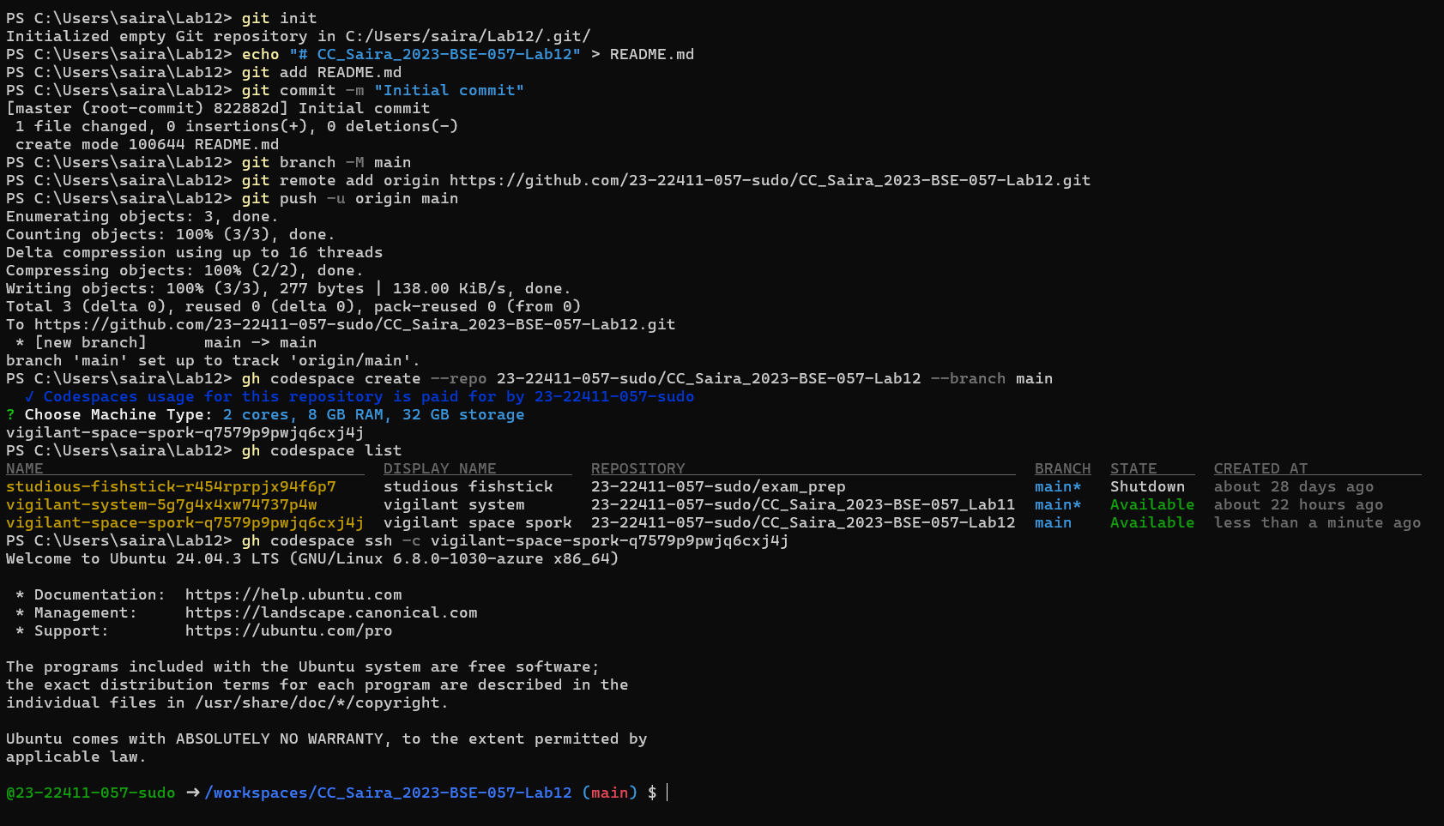
- task0_codespace_ssh_connected.png
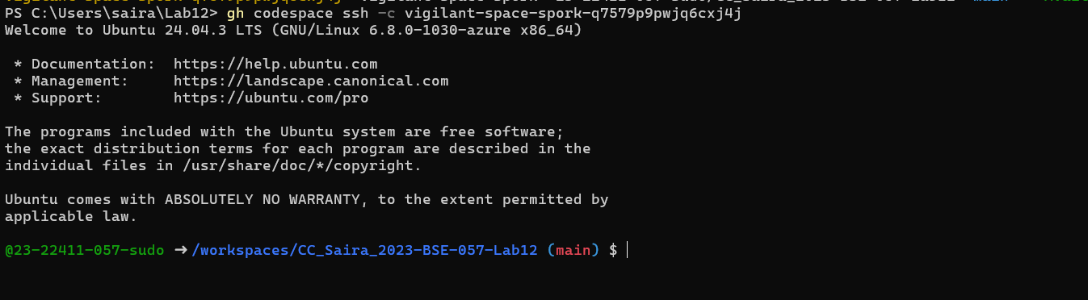
Task 1 — Organize Terraform code into separate files
- task1_project_directory.png
- task1_files_created.png
- task1_variables_tf.png
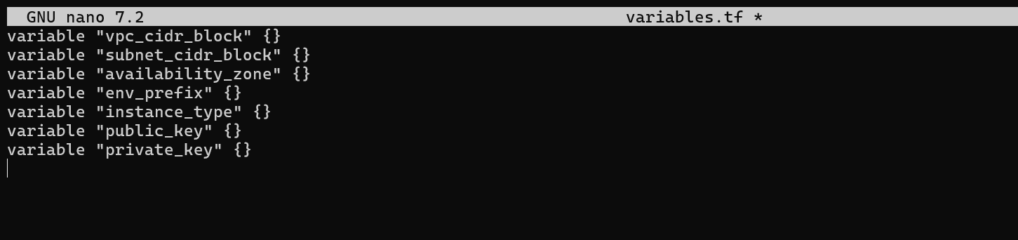
- task1_outputs_tf.png
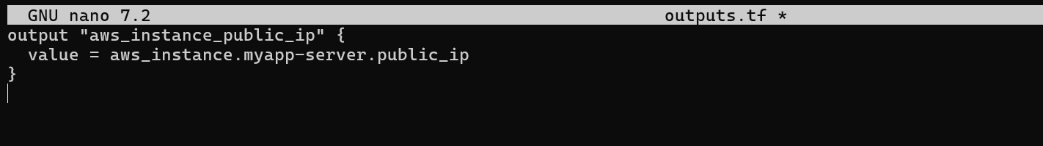
- task1_locals_tf.png
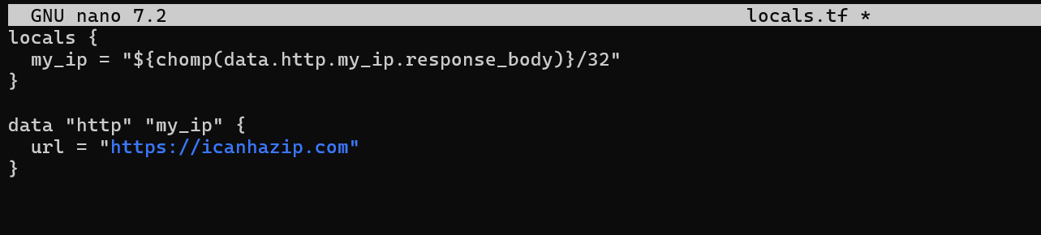
- task1_terraform_tfvars.png
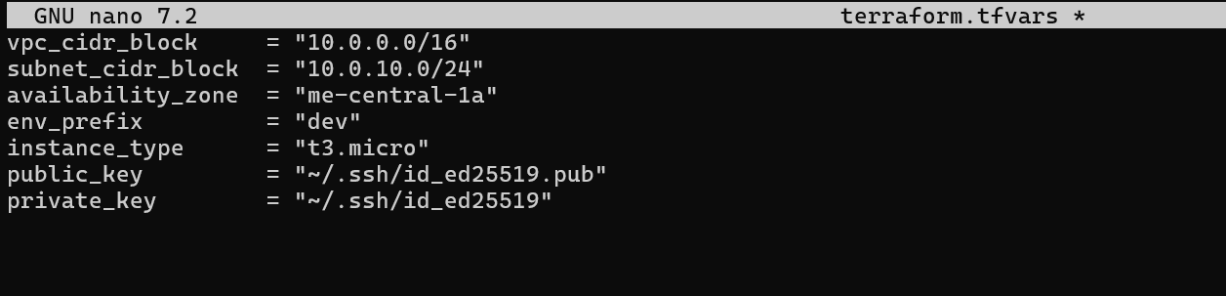
- task1_main_tf.png
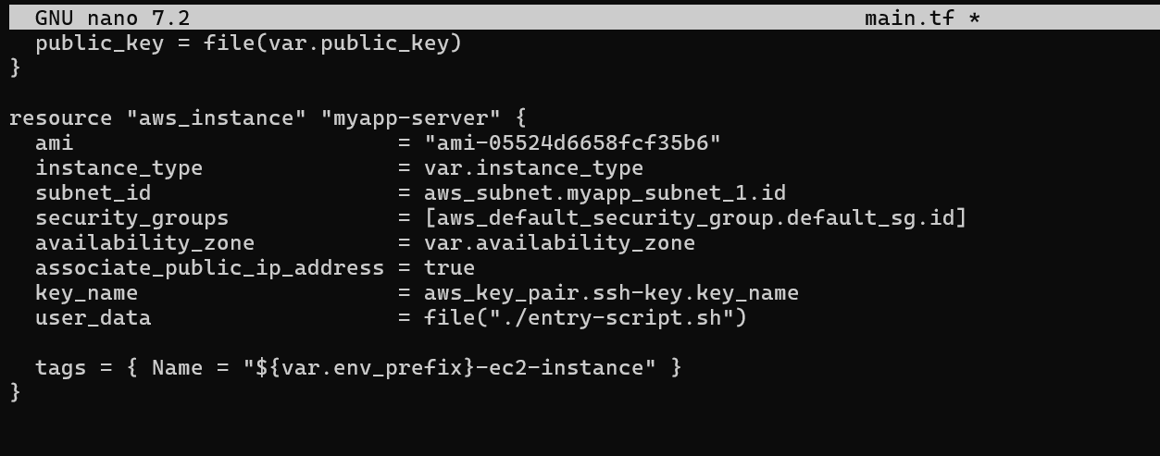
- task1_entry_script.png
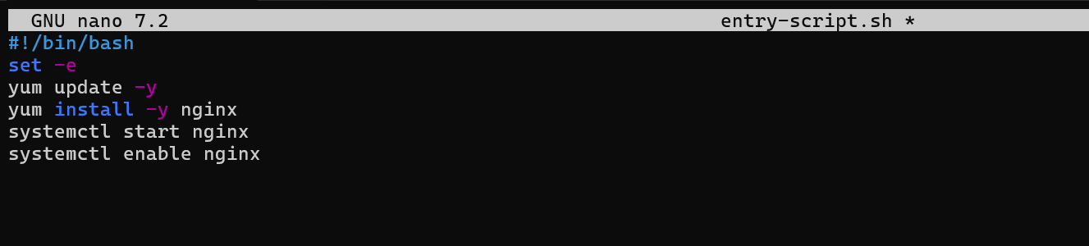
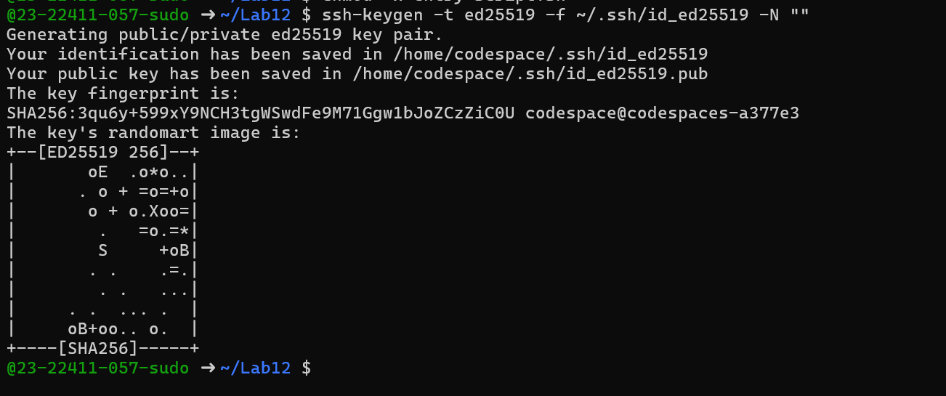
- task1_ssh_keygen.png
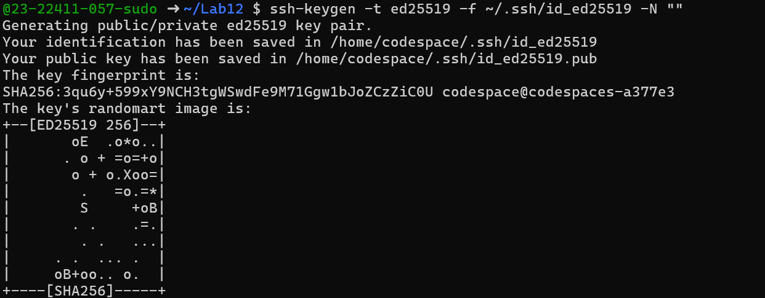
- task1_terraform_init.png
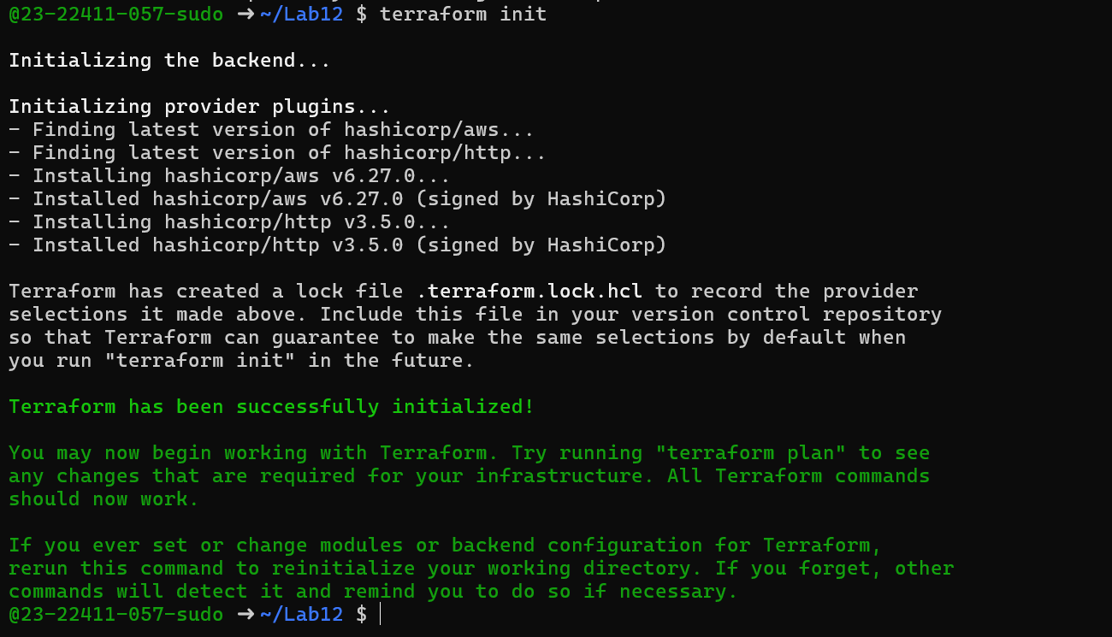
- task1_terraform_apply.png
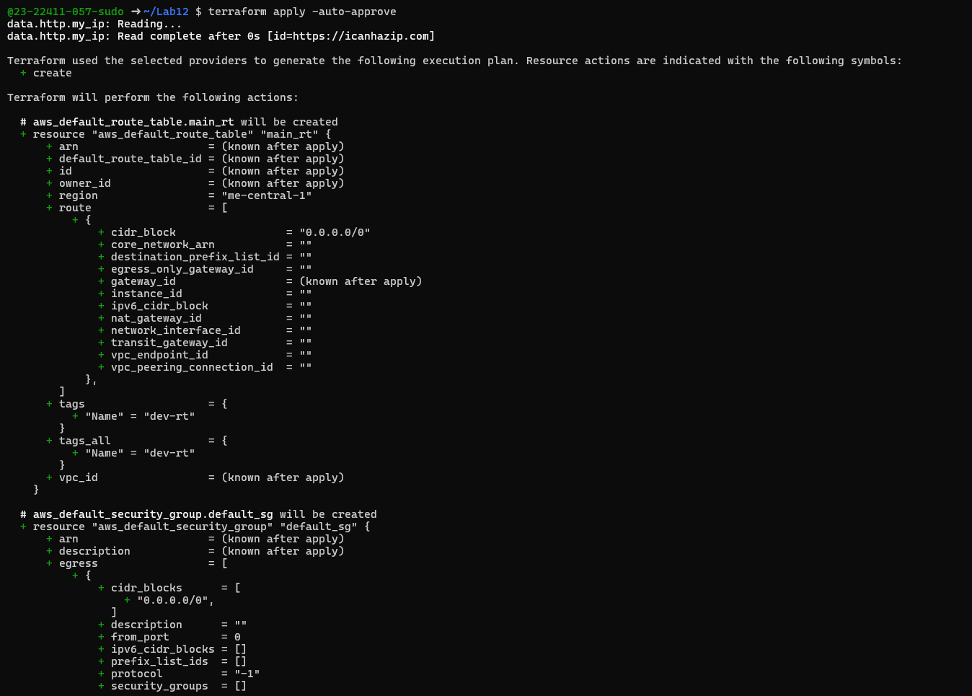
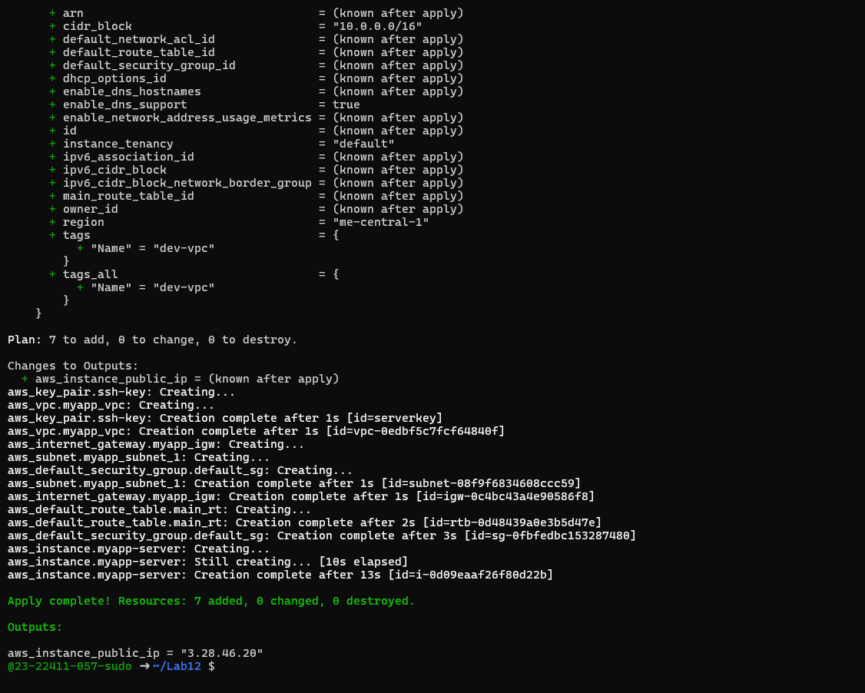
- task1_terraform_output.png
- task1_nginx_browser.png

- task1_terraform_destroy.png
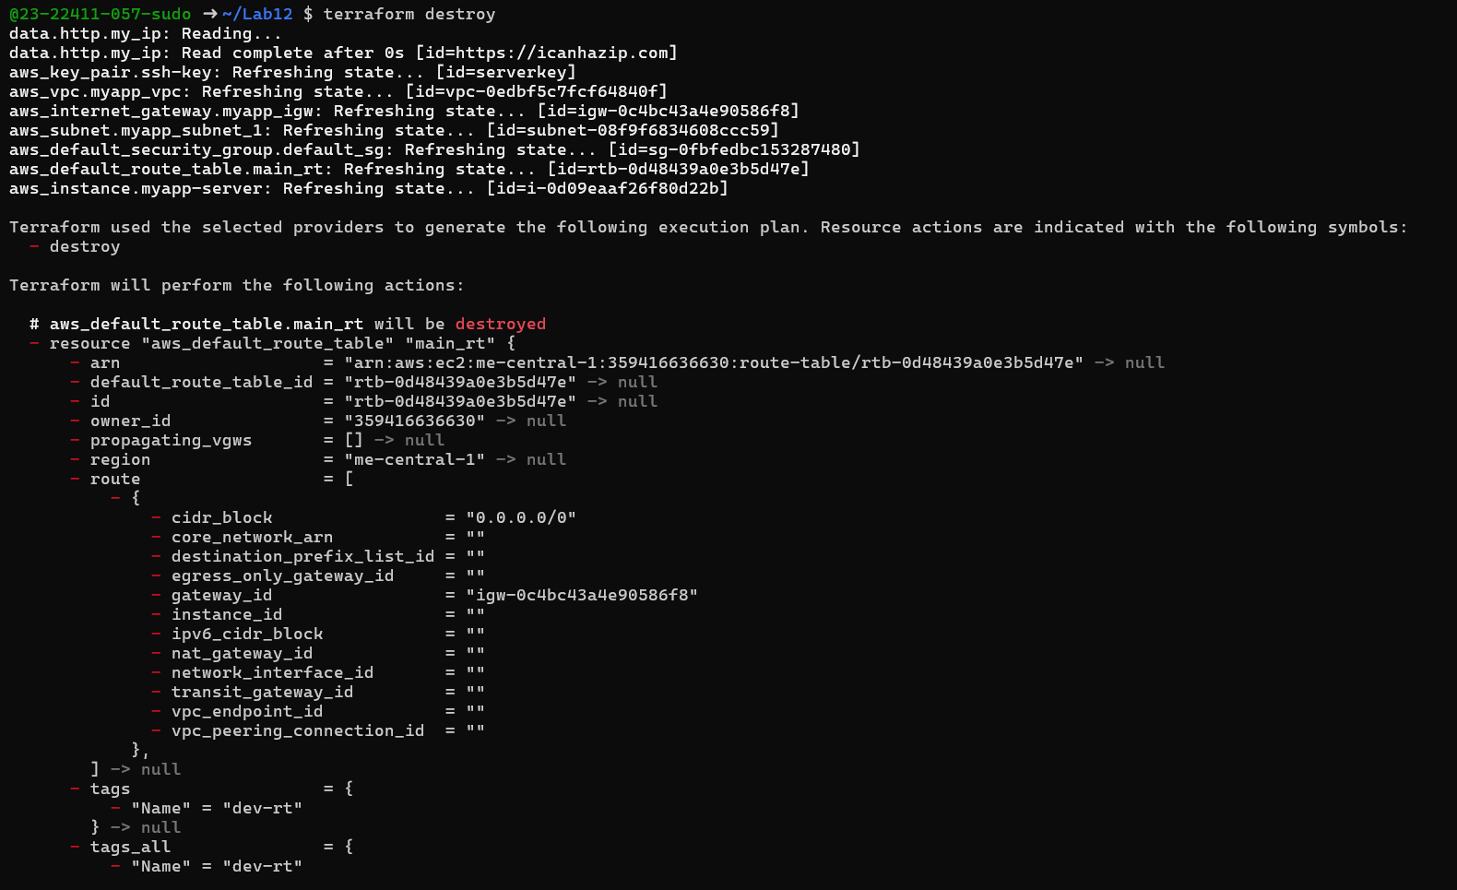
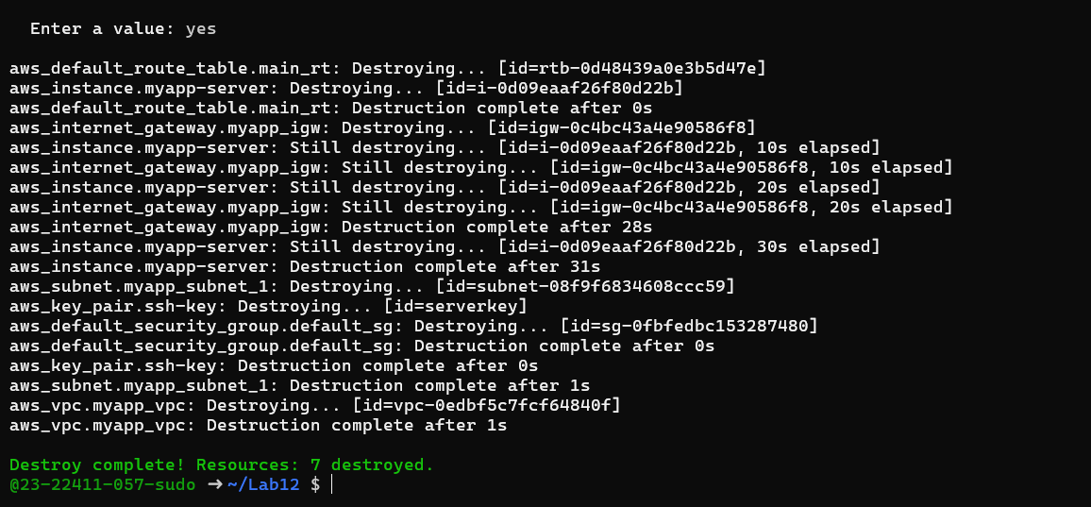
Task 2 — Use remote-exec provisioner
task2_main_tf_remote_exec.png
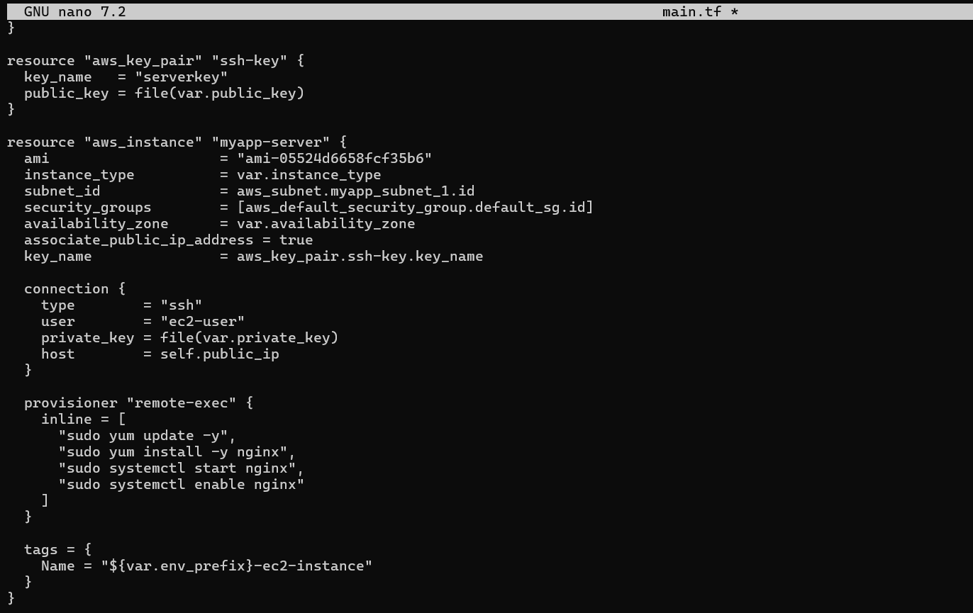
task2_terraform_apply.png
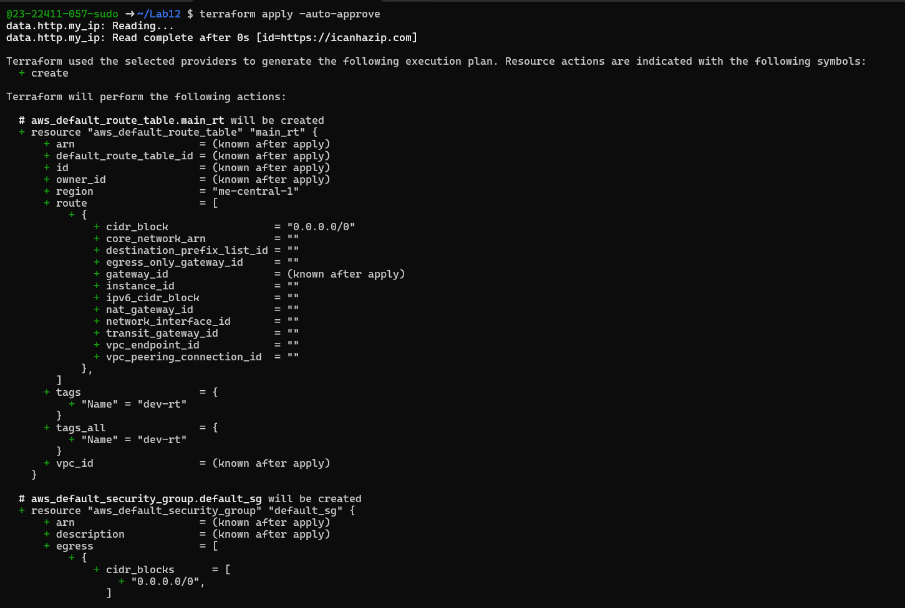
task2_terraform_output.png
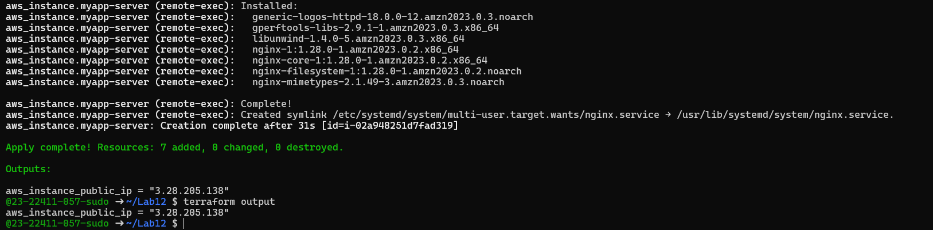
task2_nginx_browser.png
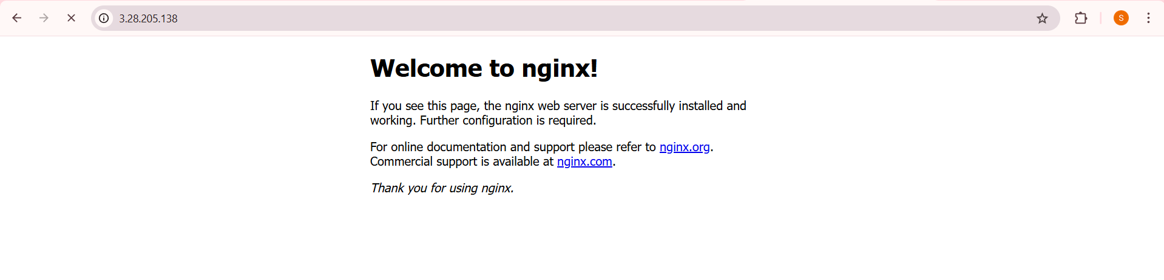
Task 3 — Use file and local-exec provisioners
task3_main_tf_all_provisioners.png
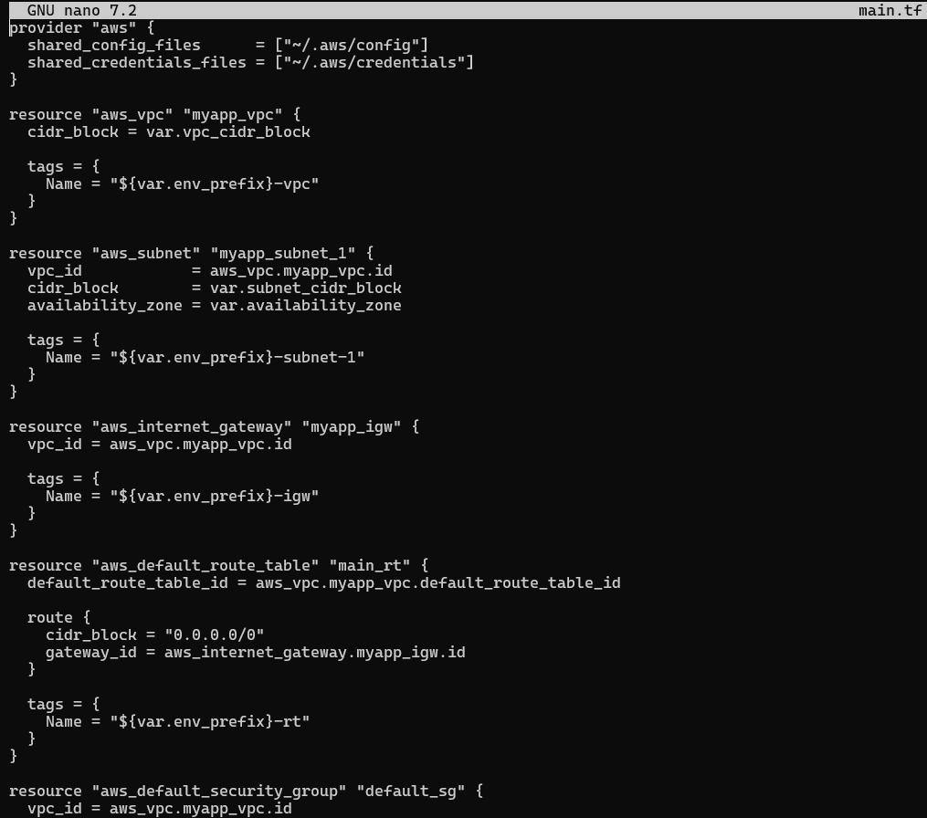
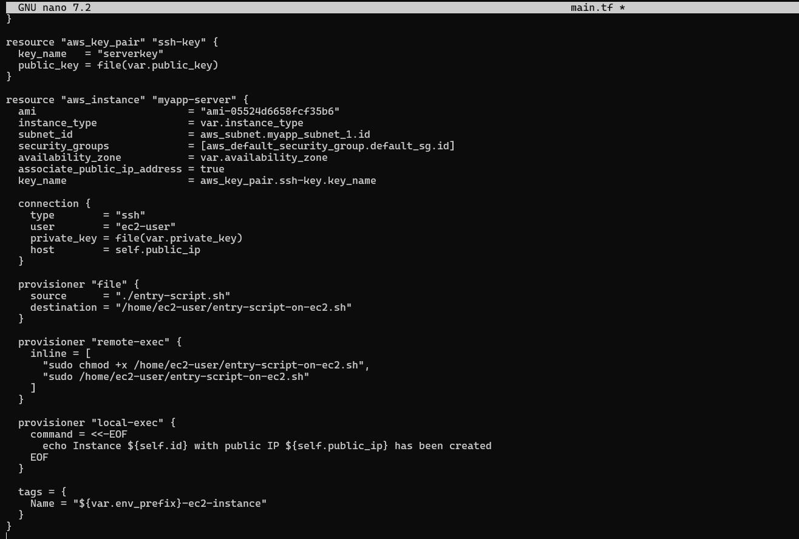
task3_terraform_apply.png
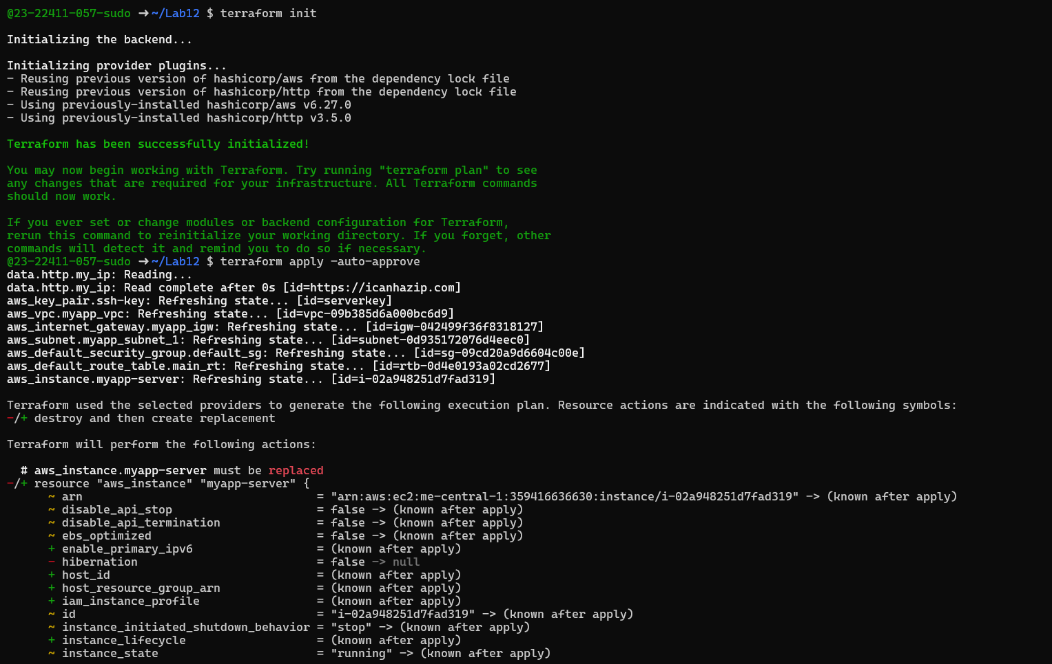
task3_terraform_output.png
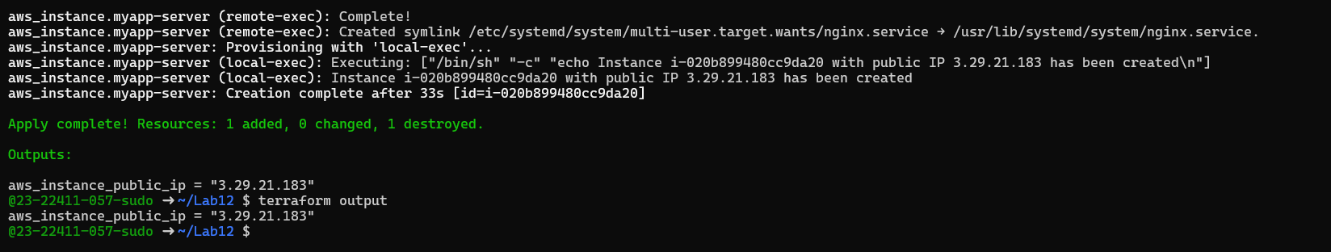
task3_nginx_browser.png

task3_terraform_destroy.png
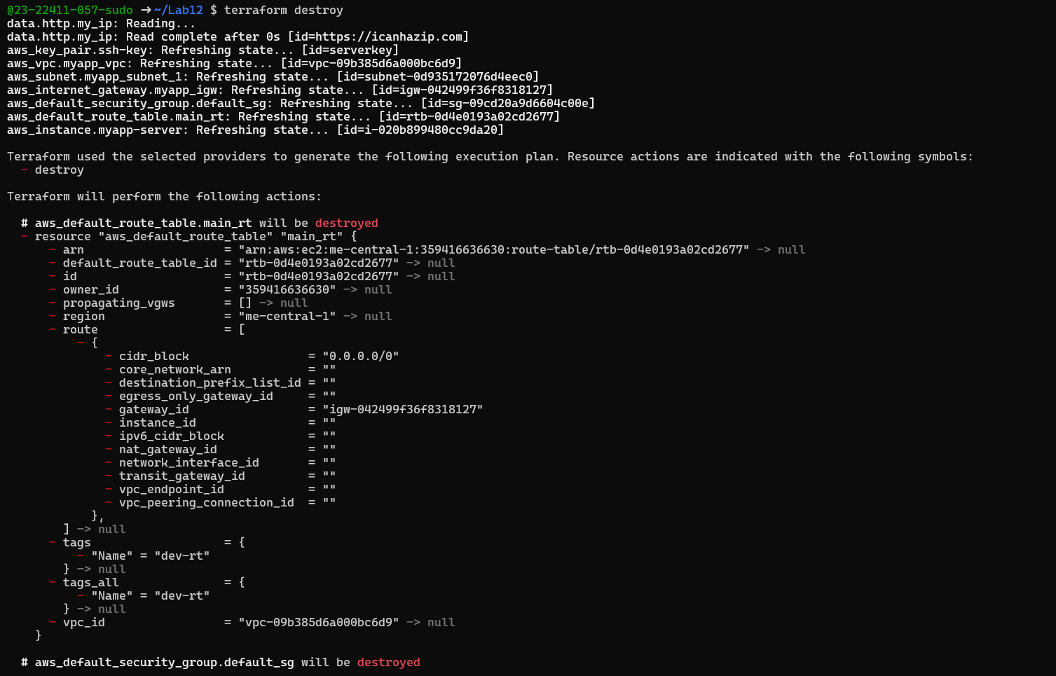
task3_main_tf_restored.png
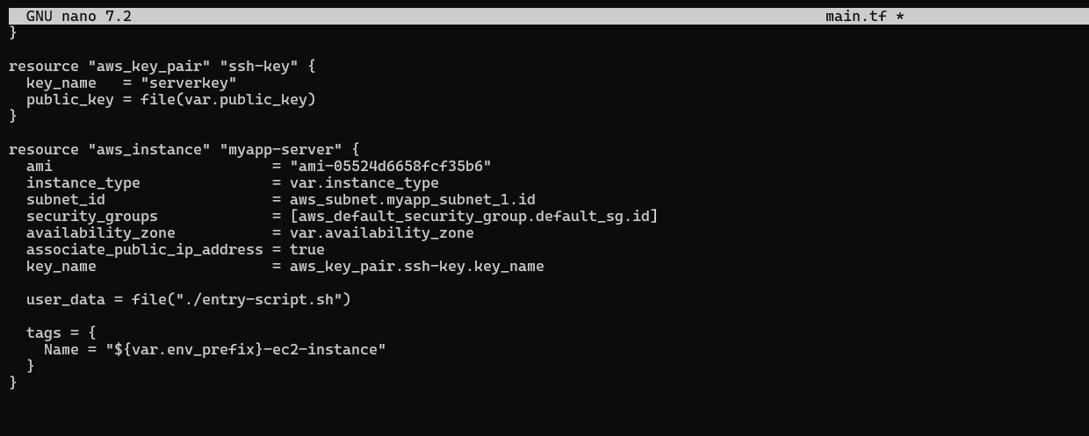
Task 4 — Create Terraform modules (subnet module)
- task4_module_structure.png
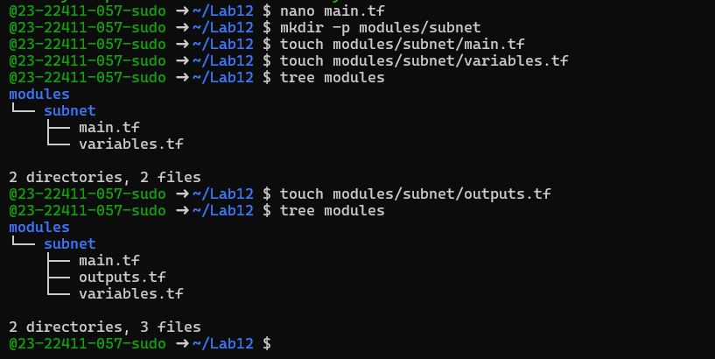
- task4_subnet_variables.png
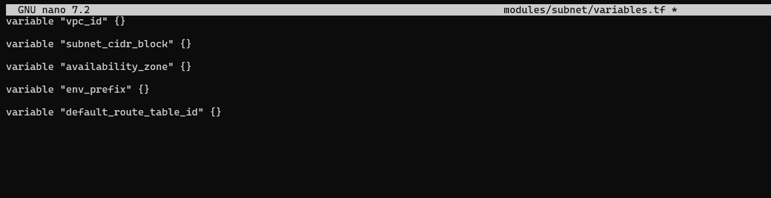
- task4_subnet_main.png
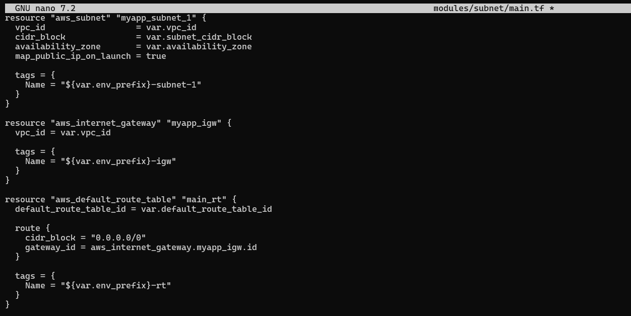
- task4_subnet_outputs.png
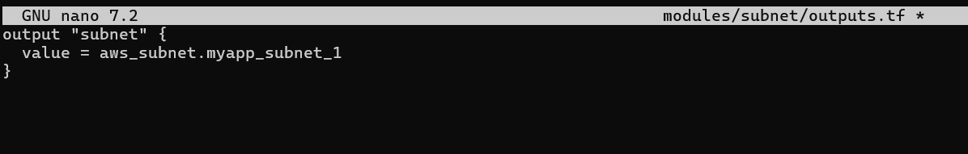
- task4_main_tf_with_module.png
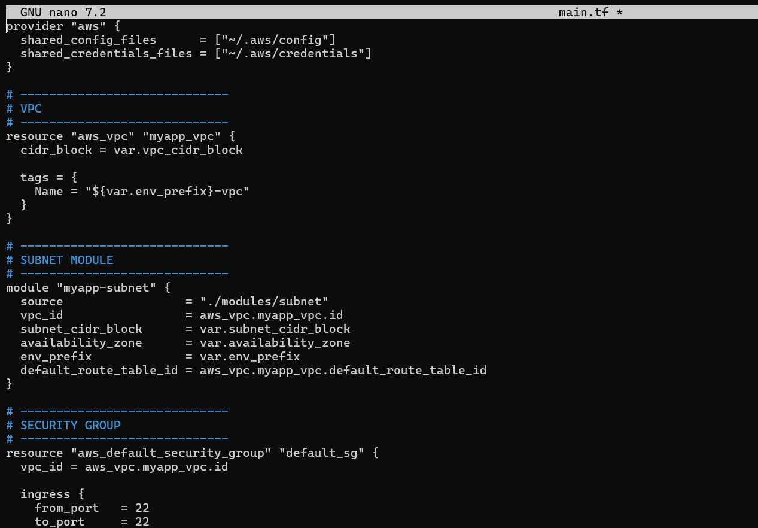
- task4_terraform_init.png
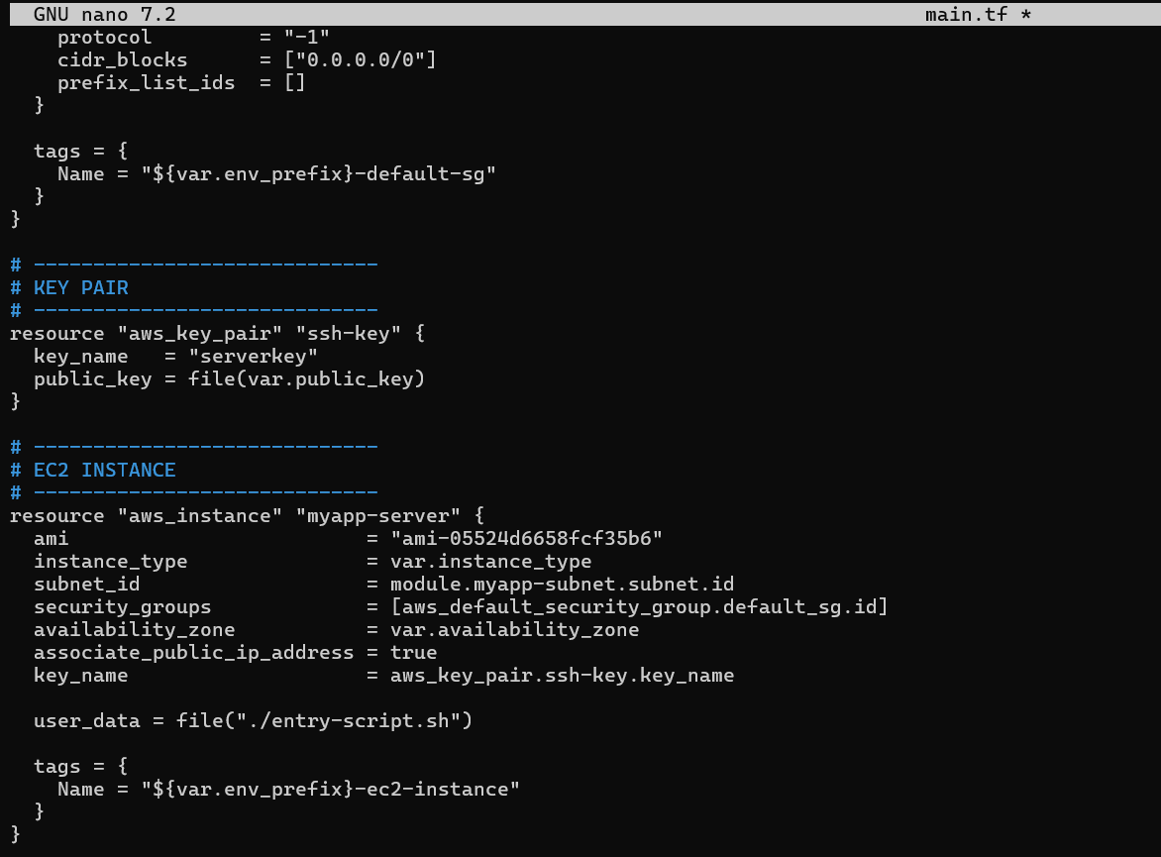
- task4_terraform_apply.png
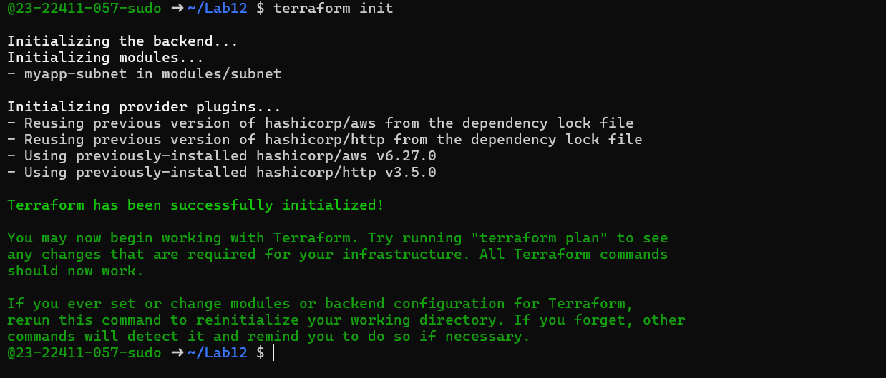
- task4_terraform_output.png
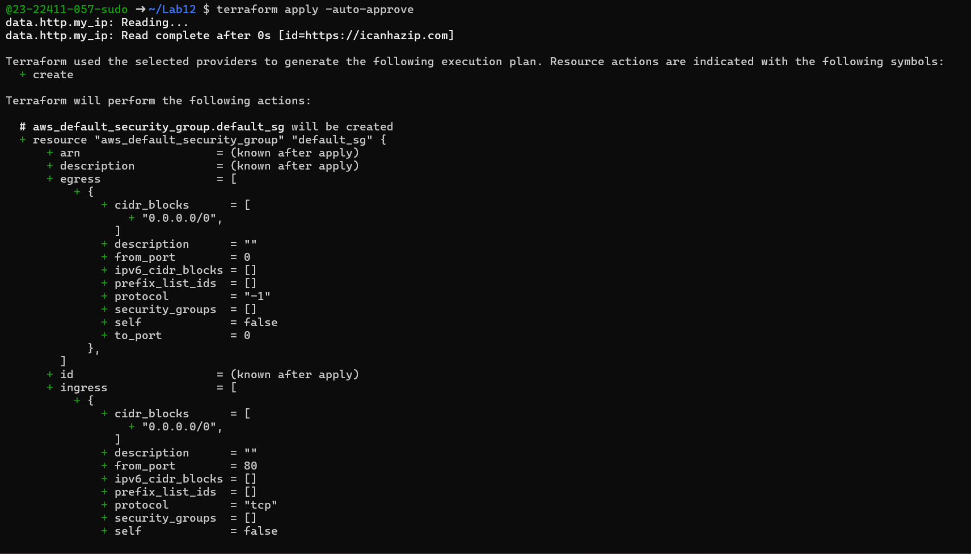
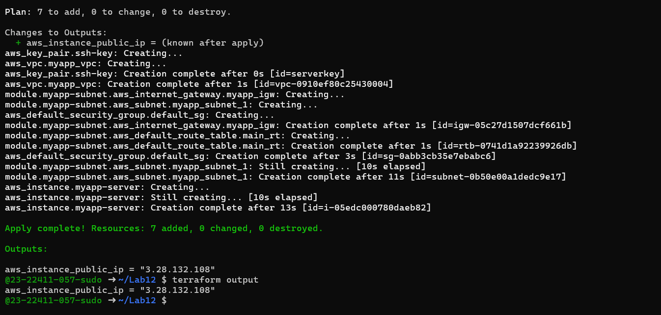
- task4_nginx_browser.png
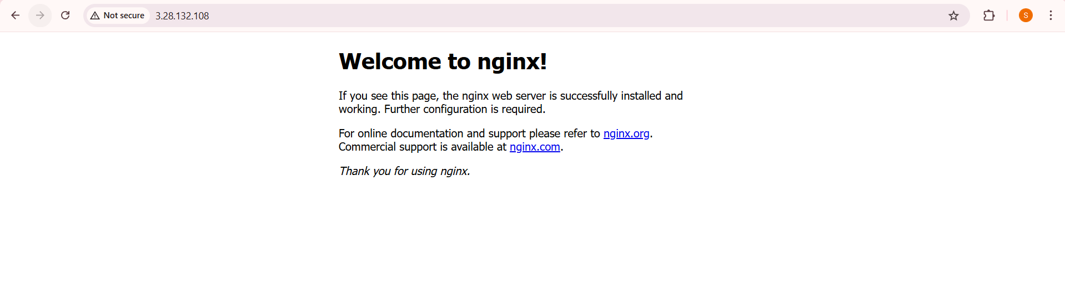
Task 5 — Create webserver module
- task5_webserver_module_structure.png
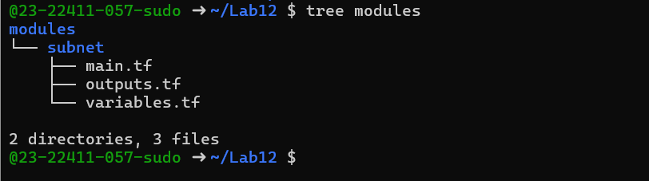
- task5_webserver_variables.png
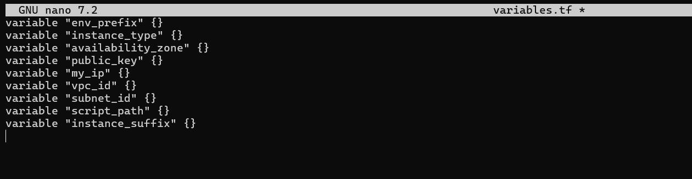
- task5_webserver_main.png
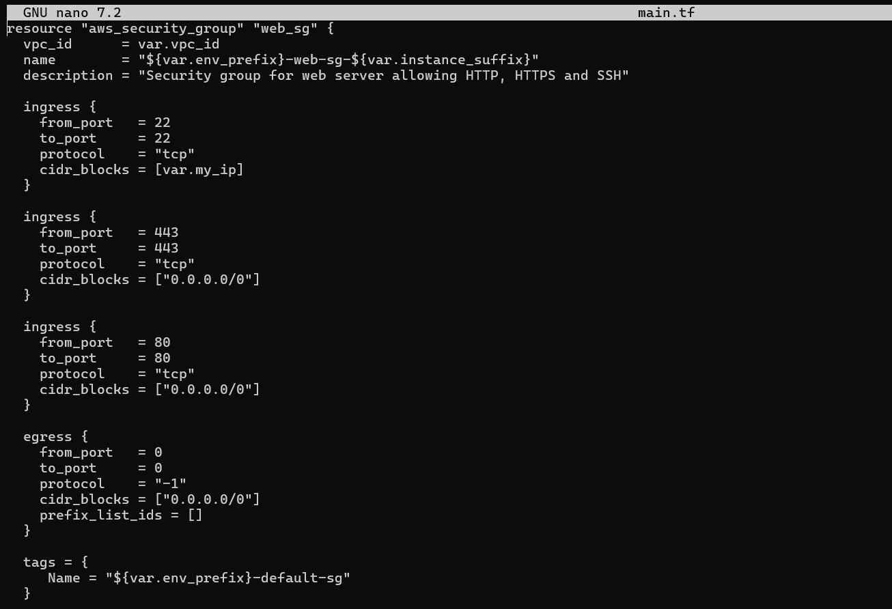
- task5_webserver_outputs.png
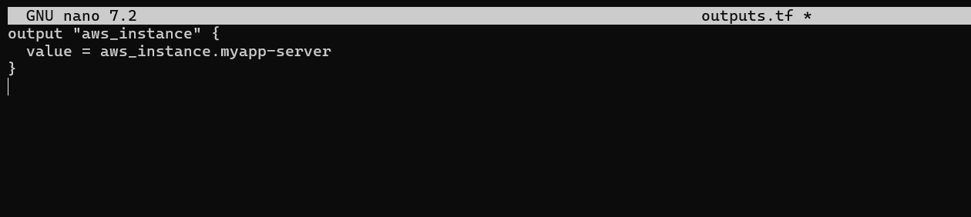
- task5_main_tf_webserver_module.png
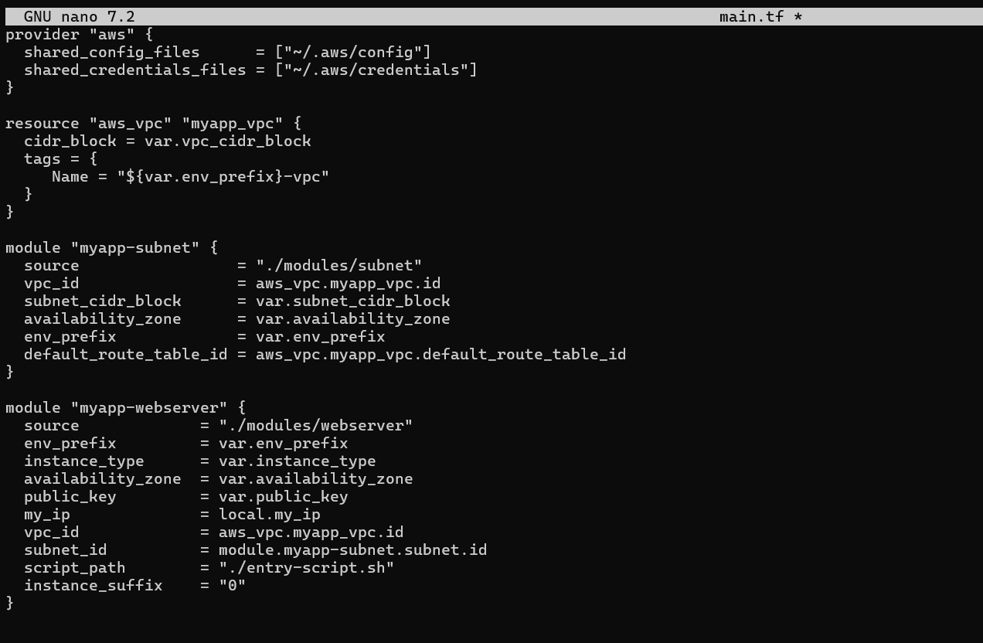
- task5_outputs_updated.png
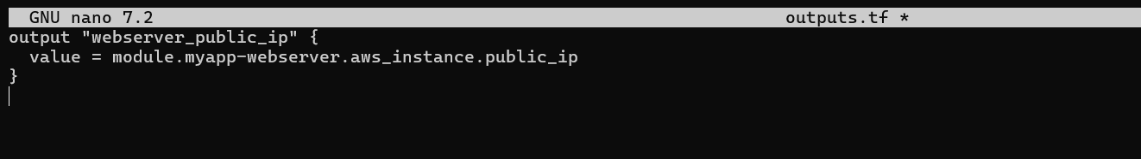
- task5_terraform_init.png
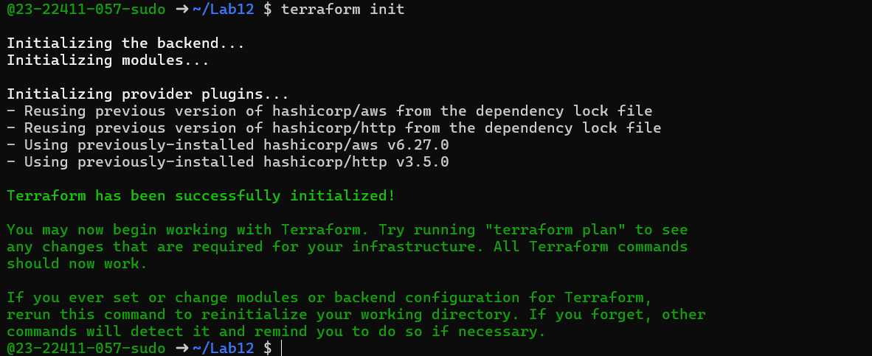
- task5_terraform_apply.png
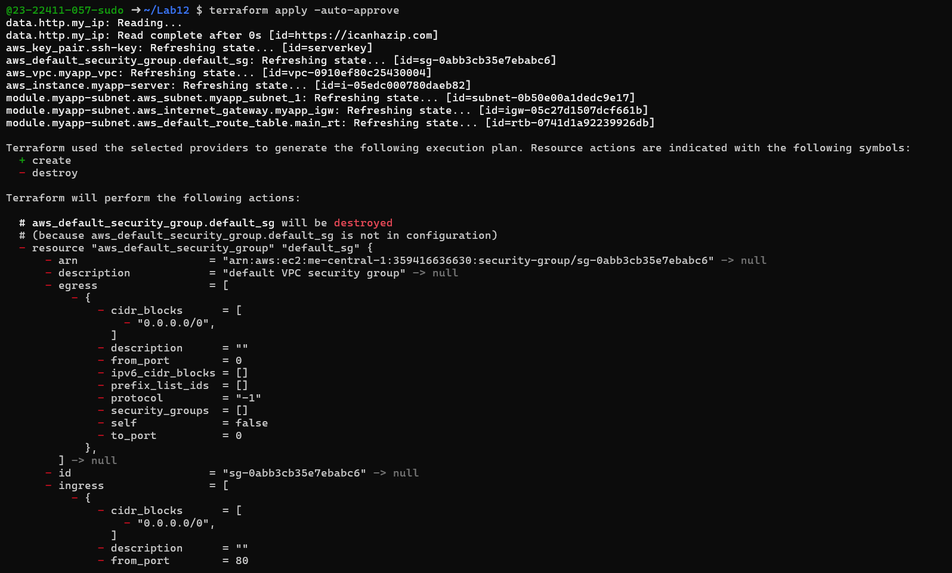
- task5_terraform_output.png
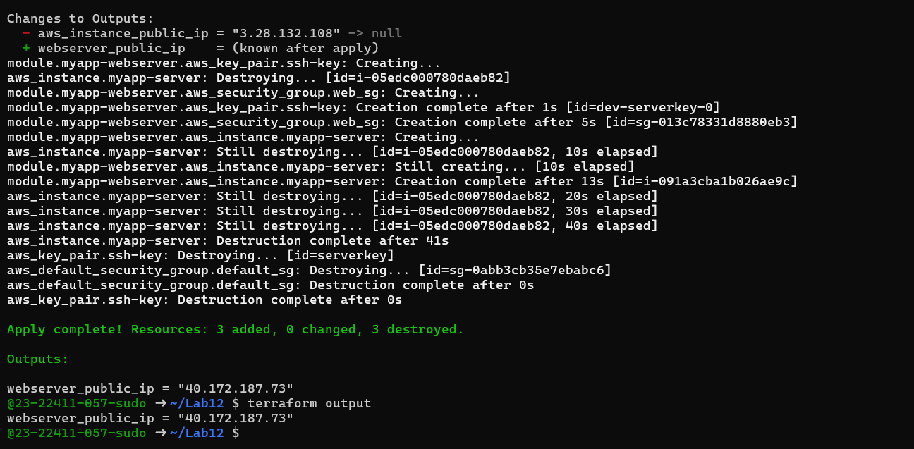
- task5_nginx_browser.png

- task5_terraform_destroy.png
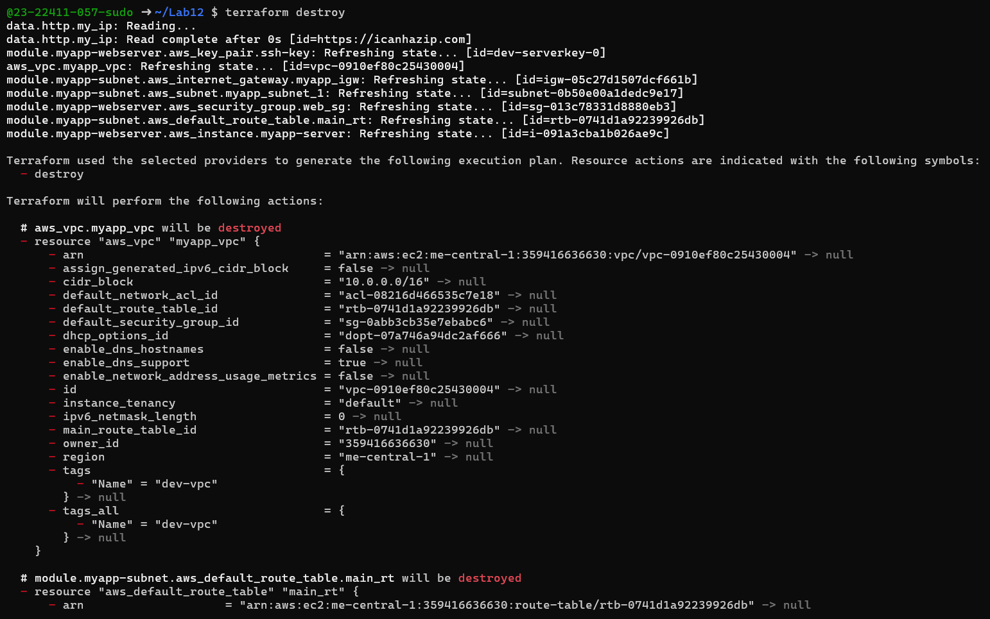
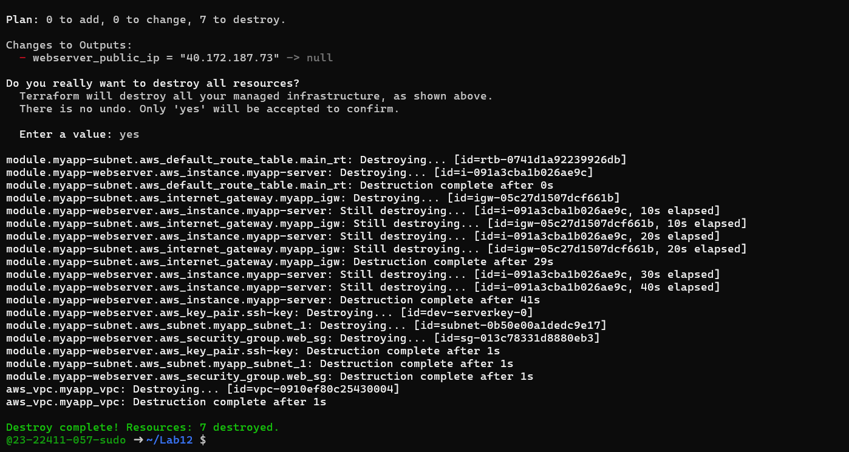
Task 6 — Configure HTTPS with self-signed certificates
- task6_entry_script_https.png
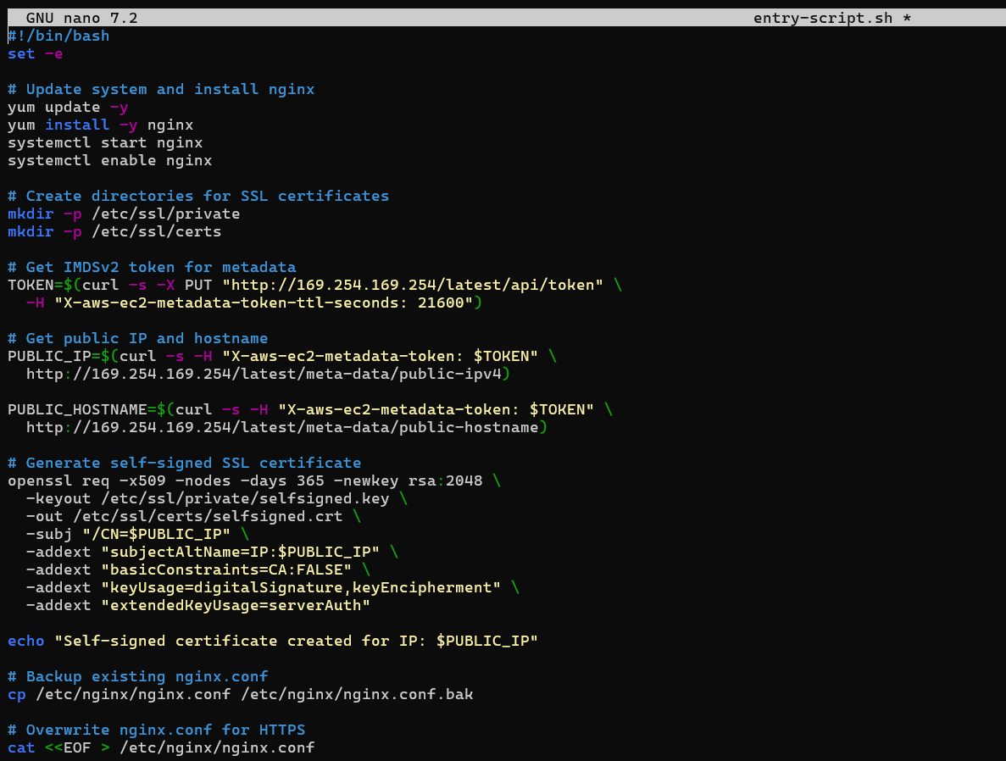
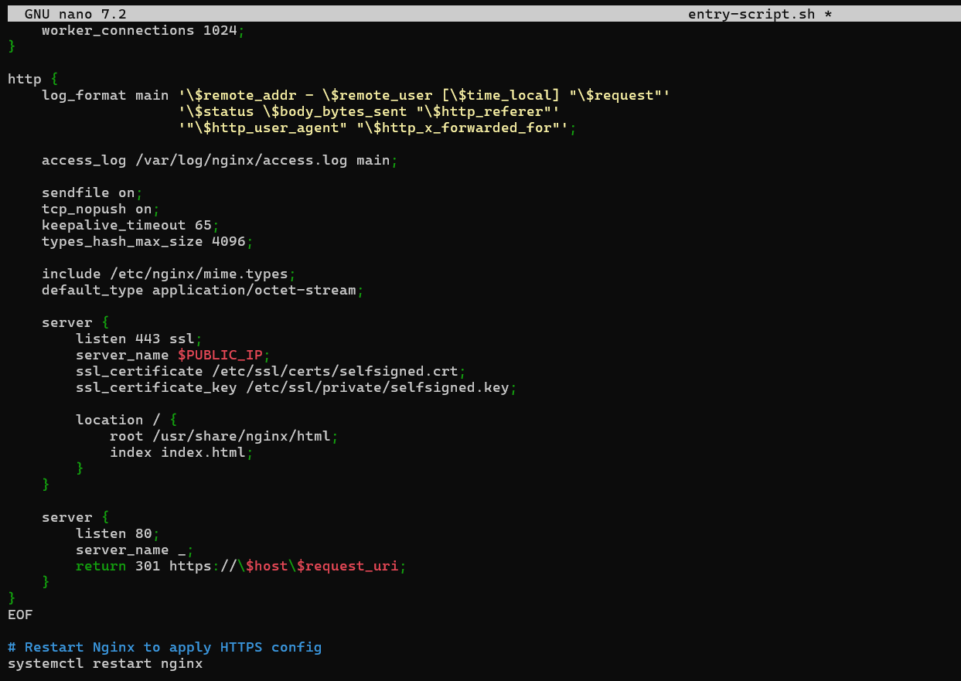
- task6_terraform_apply.png
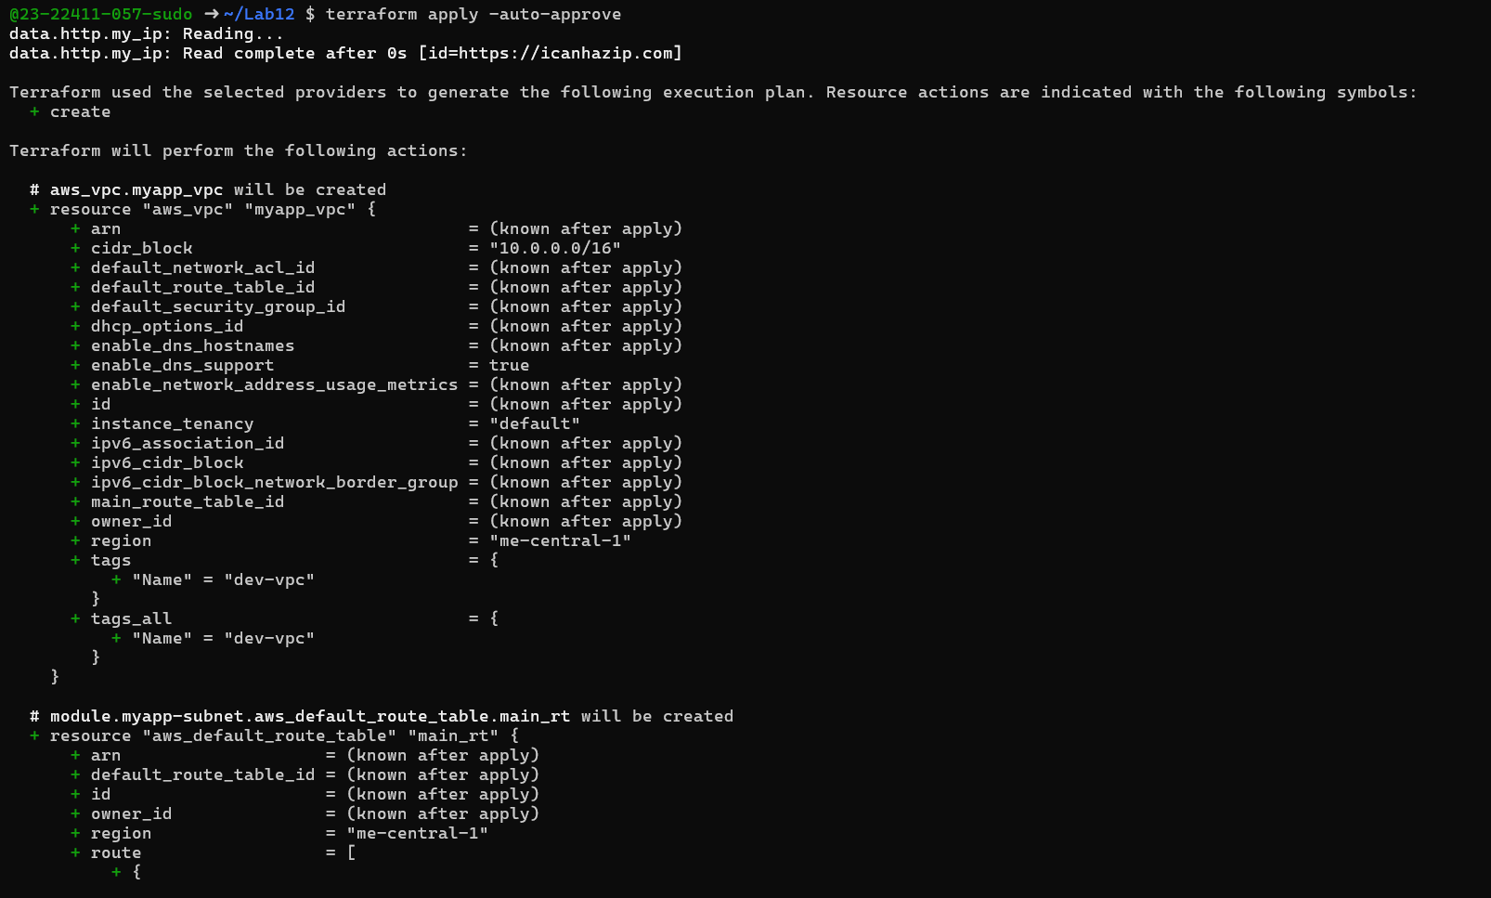
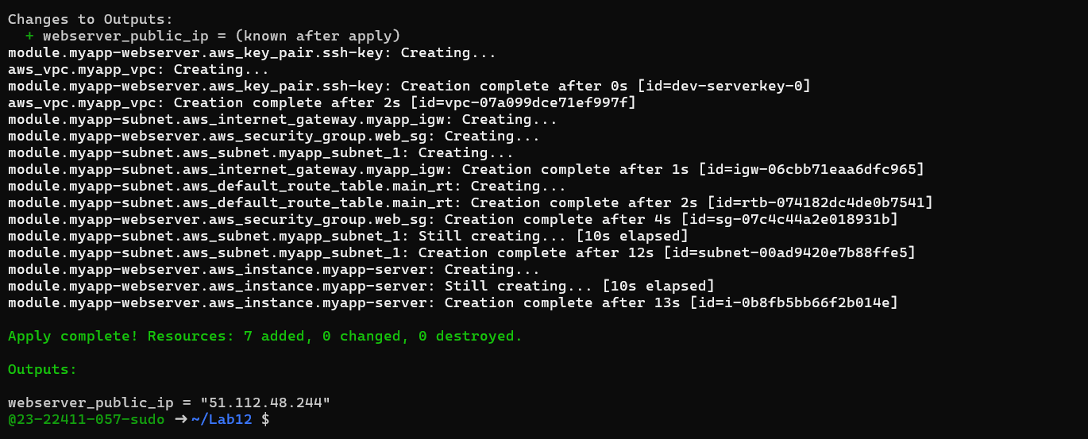
- task6_terraform_output.png
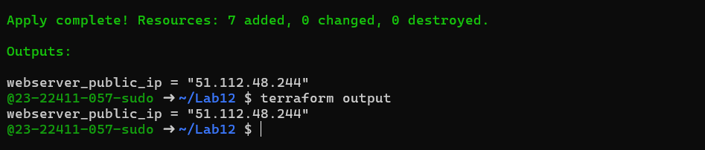
- task6_browser_security_warning.png
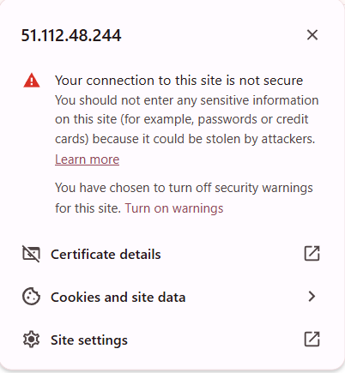
- task6_nginx_https_browser.png
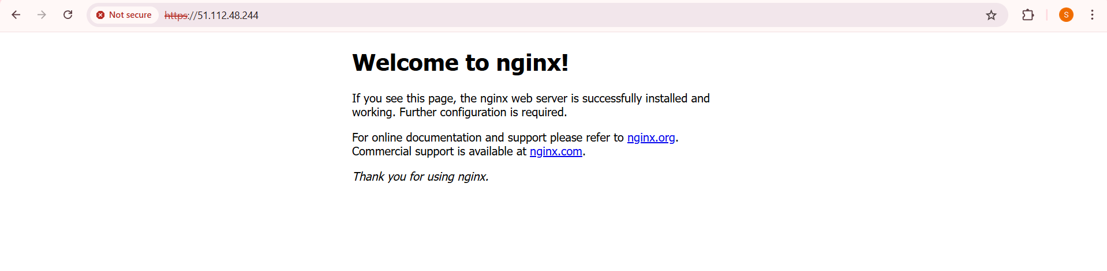
- task6_http_redirect.png
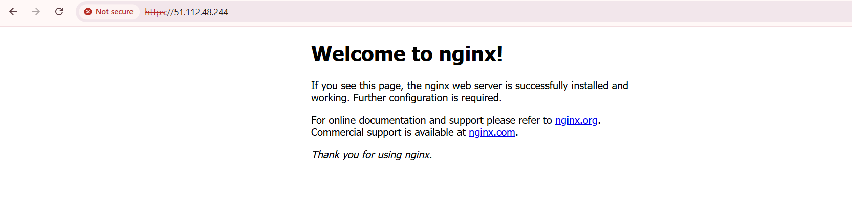
Task 7 — Configure Nginx as reverse proxy
- task7_apache_script.png
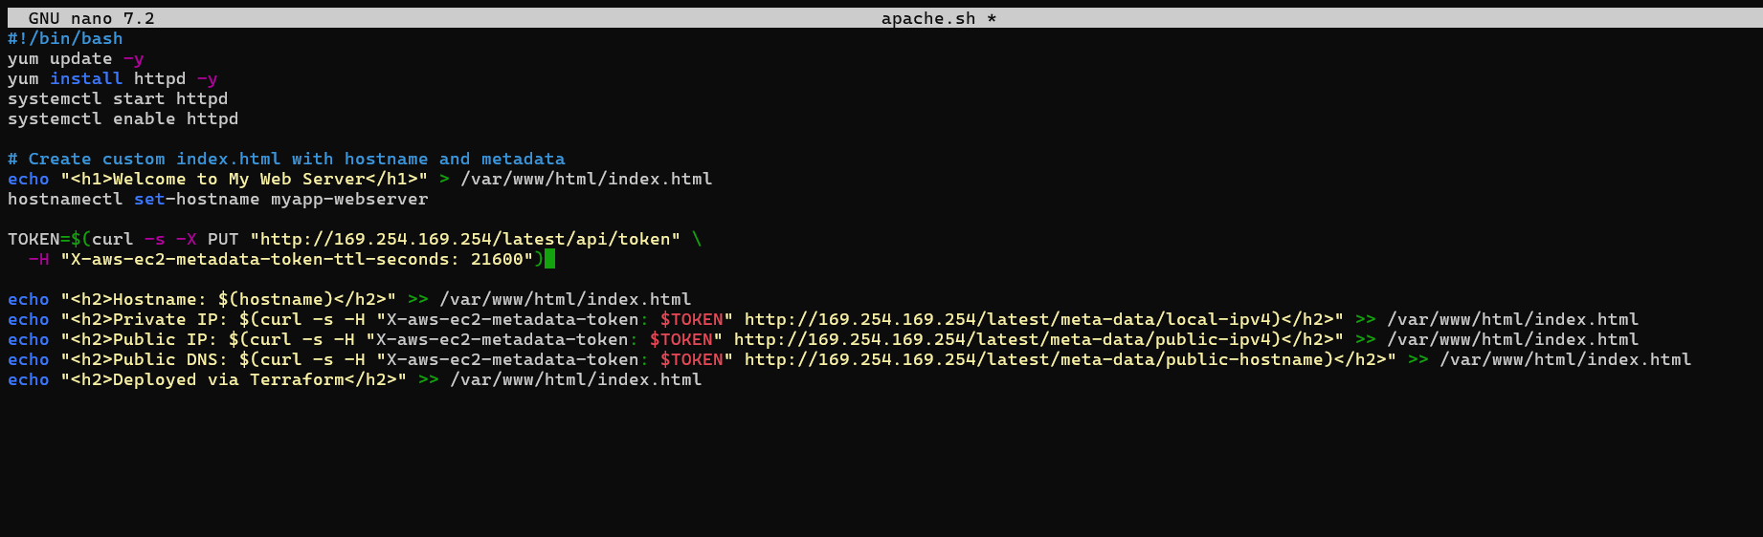
- task7_main_tf_web1.png
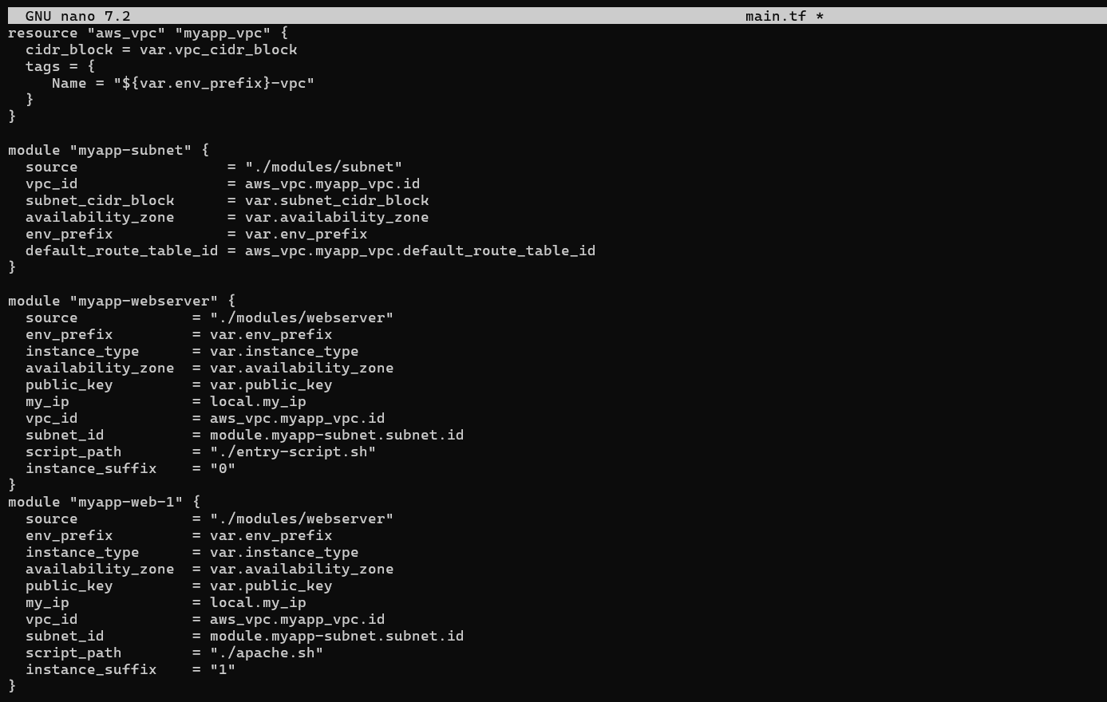
- task7_outputs_web1.png
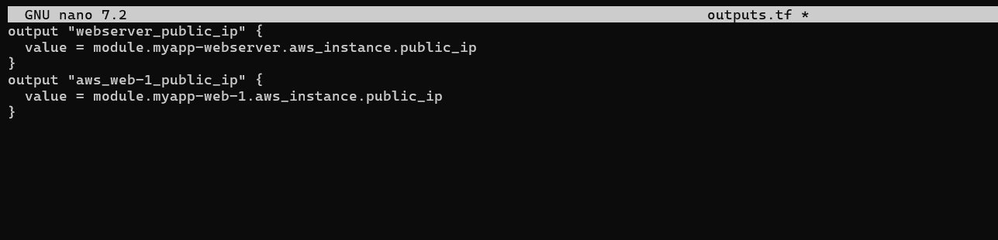
- task7_terraform_apply.png
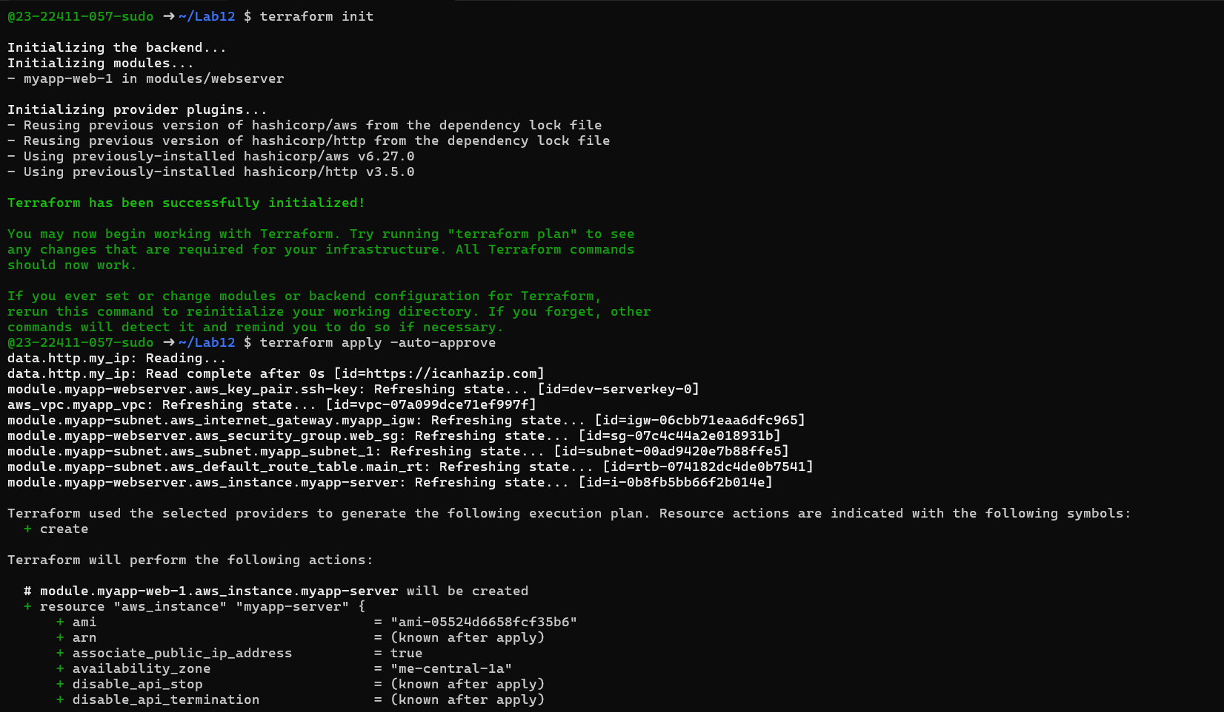
- task7_terraform_output.png
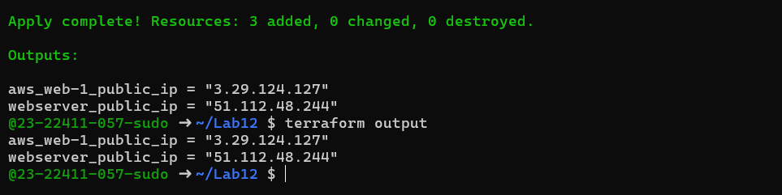
- task7_ssh_webserver.png
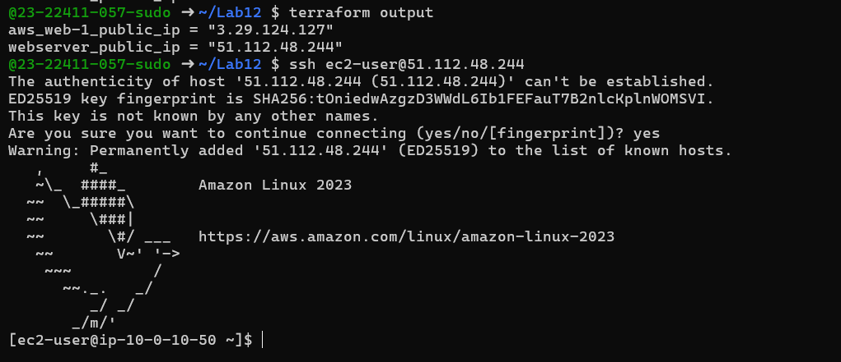
- task7_nginx_conf_reverse_proxy.png
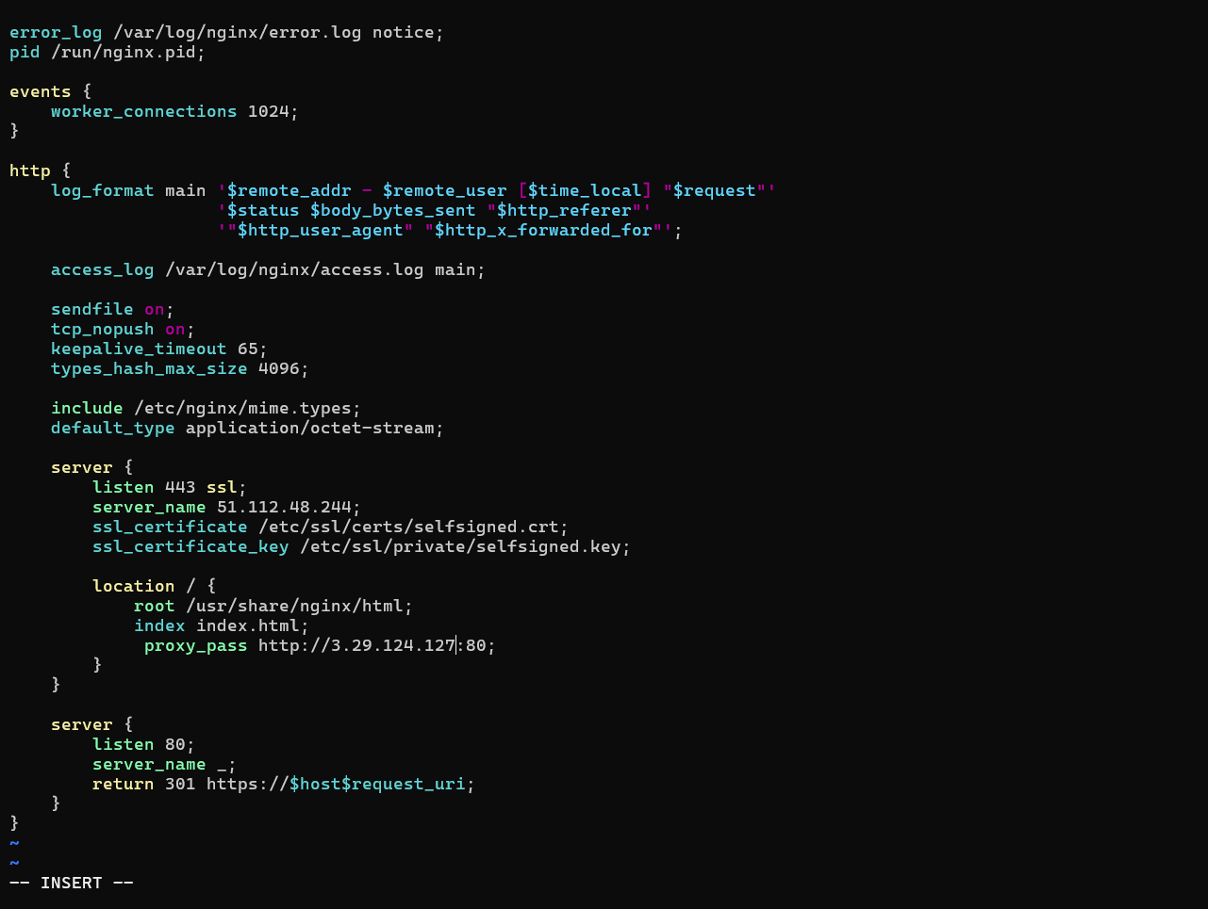
- task7_nginx_restart.png
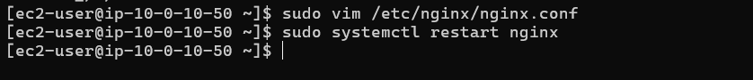
- task7_error_log.png
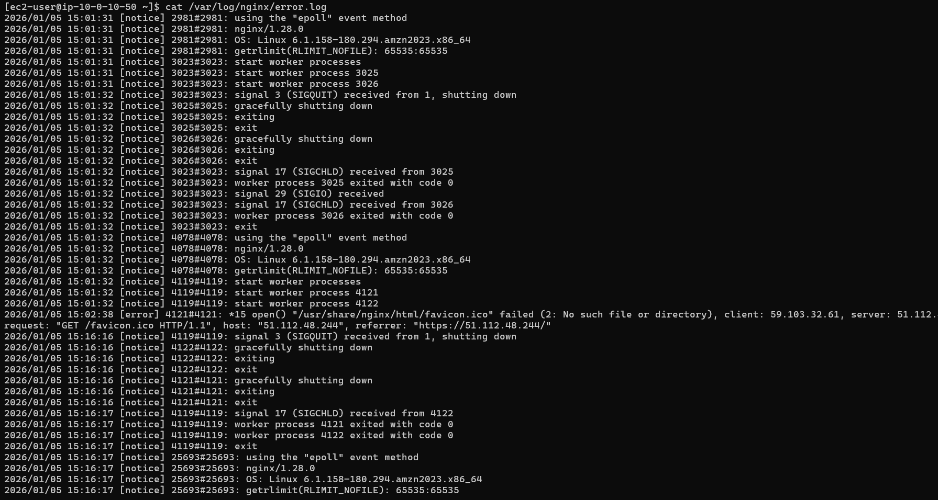
- task7_access_log.png
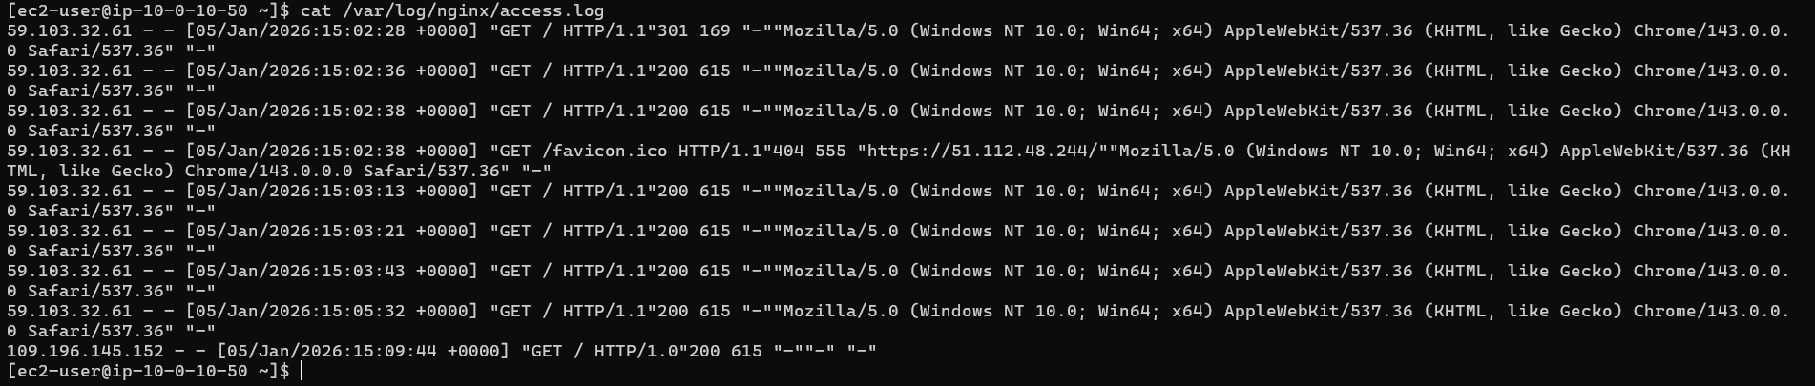
- task7_mime_types.png
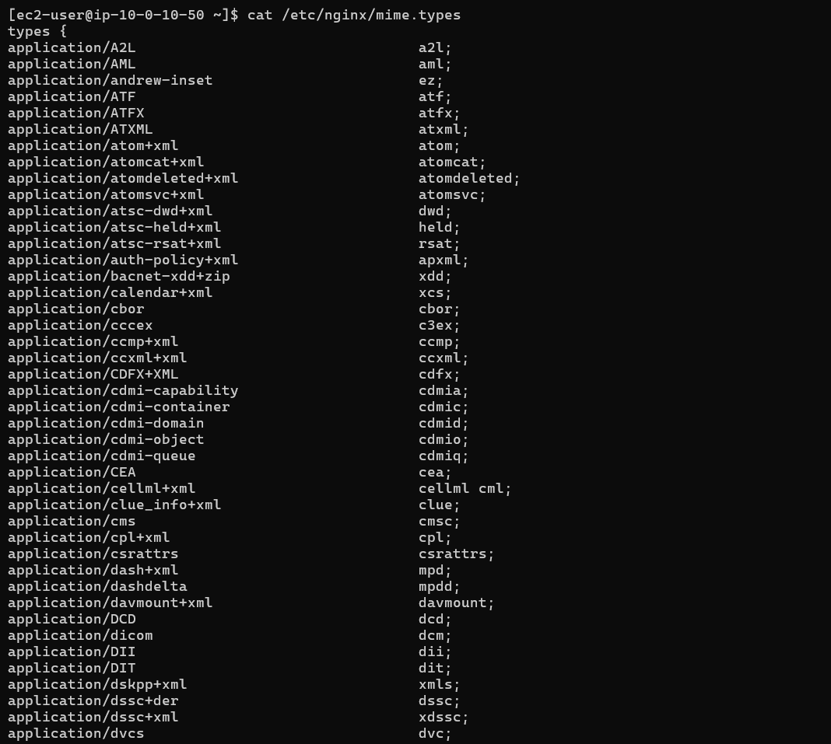
- task7_ssl_cert.png
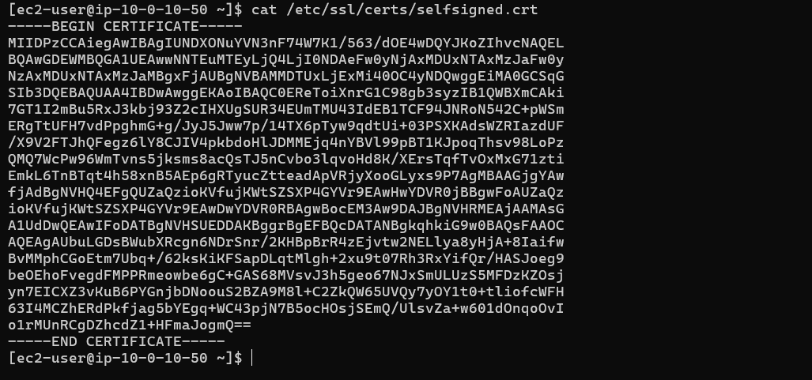
- task7_ssl_key.png
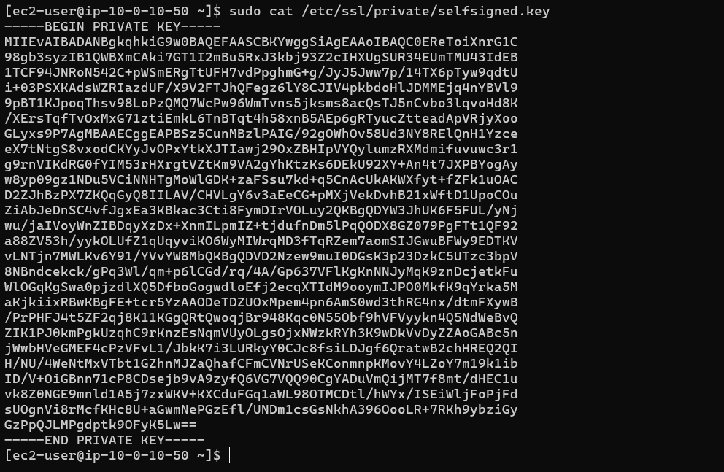
- task7_reverse_proxy_browser.png


Task 8 — Configure Nginx as load balancer
- task8_main_tf_web2.png
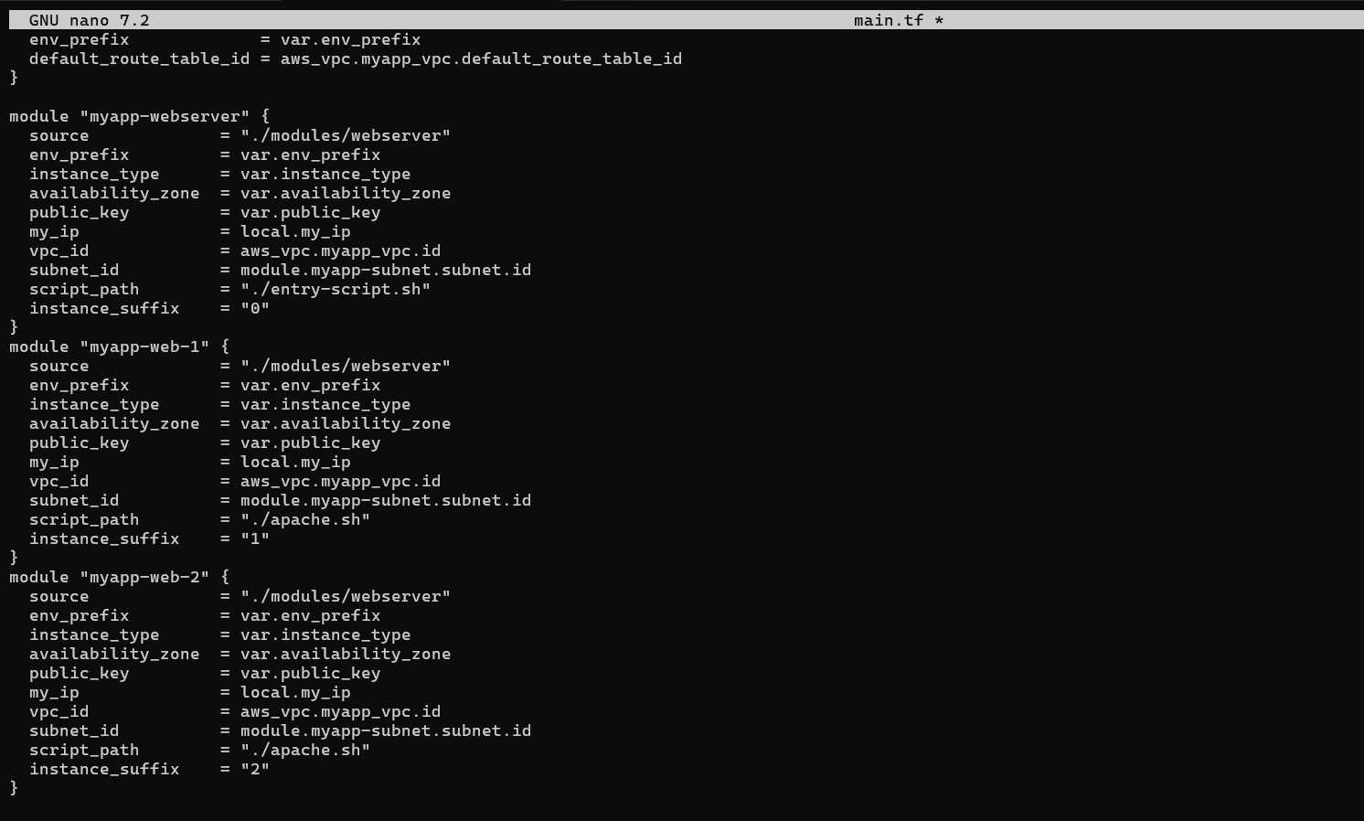
- task8_outputs_web2.png
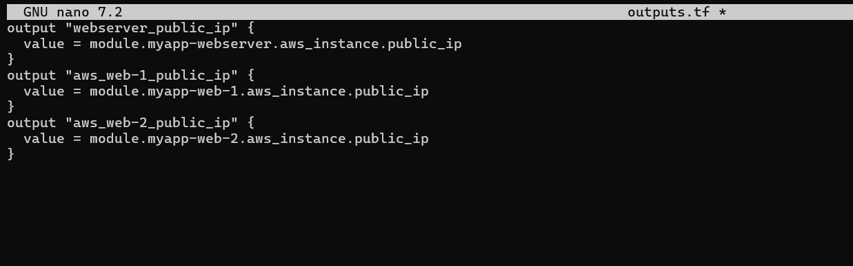
- task8_terraform_apply.png
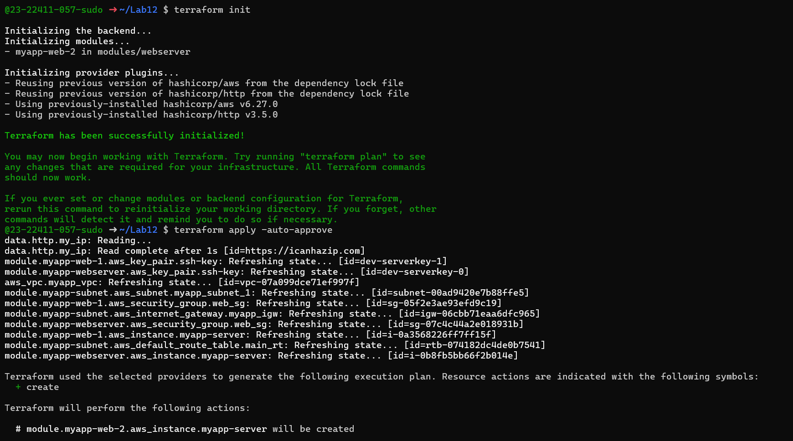
- task8_terraform_output.png
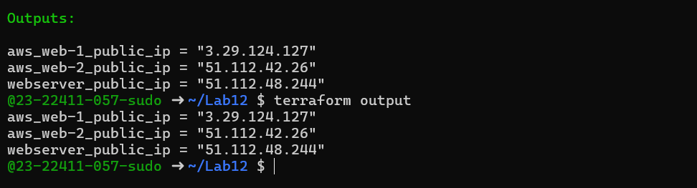
- task8_nginx_conf_load_balancer.png
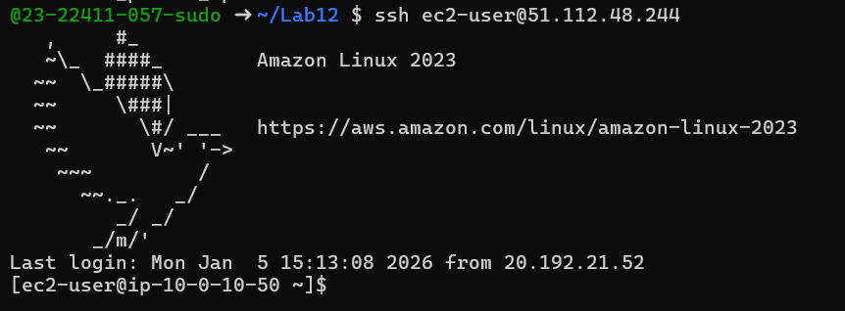
- task8_nginx_restart.png
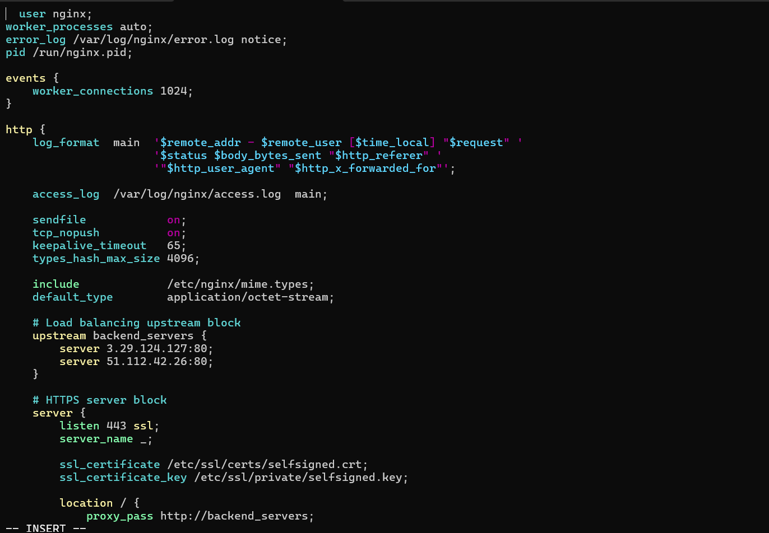
- task8_load_balancer_web1.png
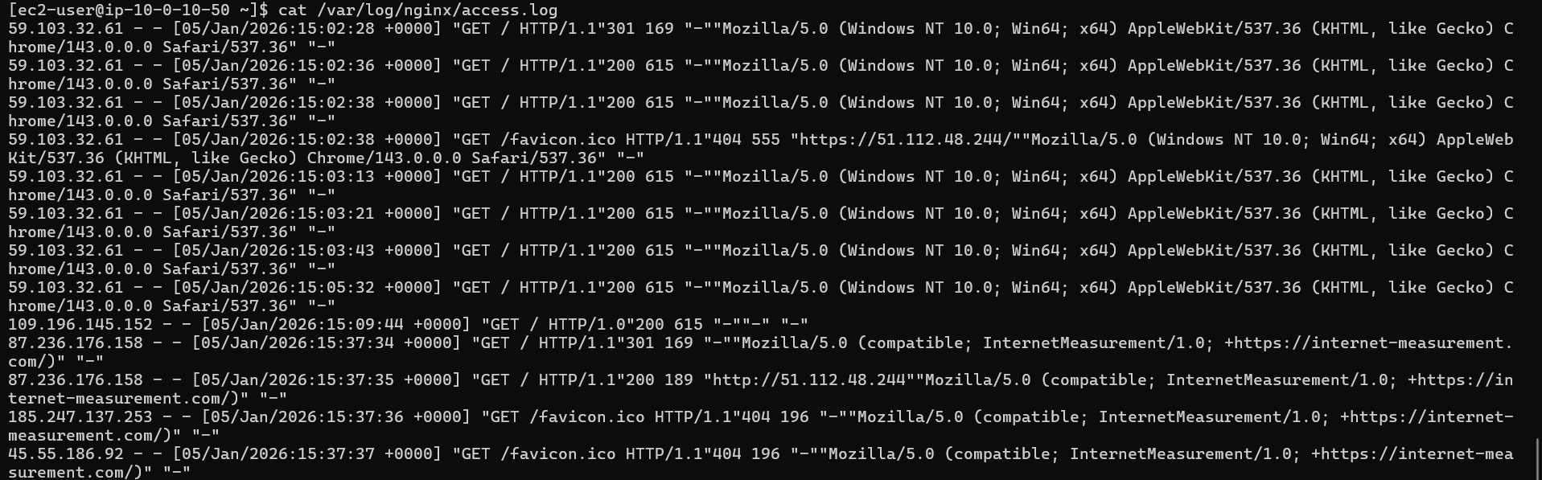
- task8_load_balancer_web2.png
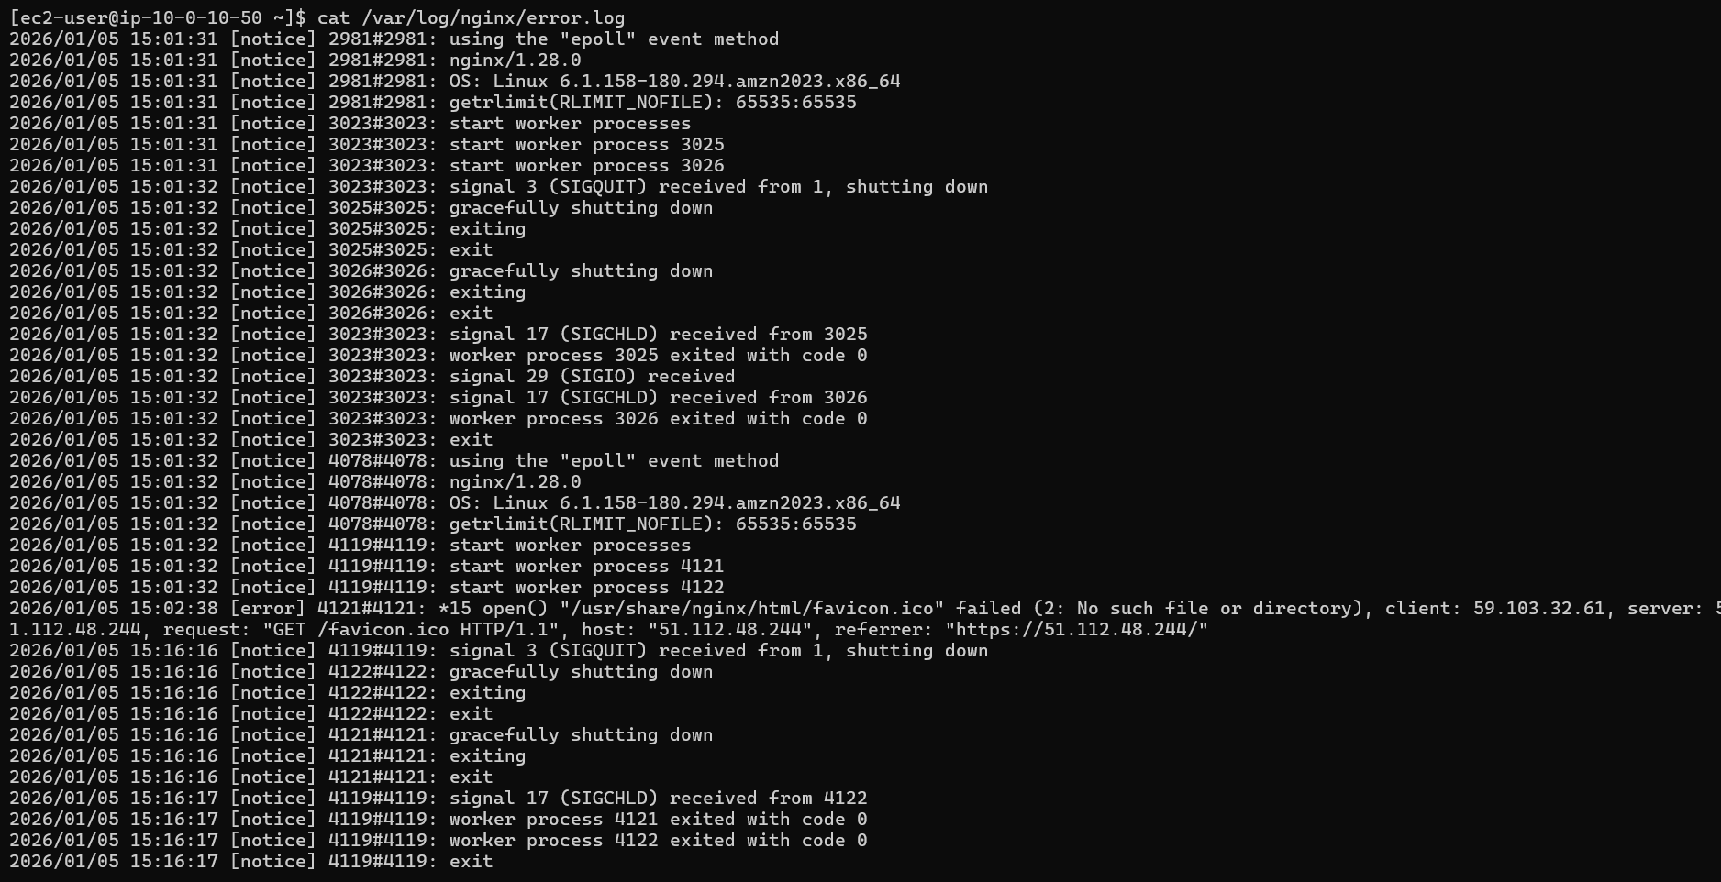
Task 9 — Configure high availability with backup servers
- task9_nginx_conf_ha_web1_primary.png
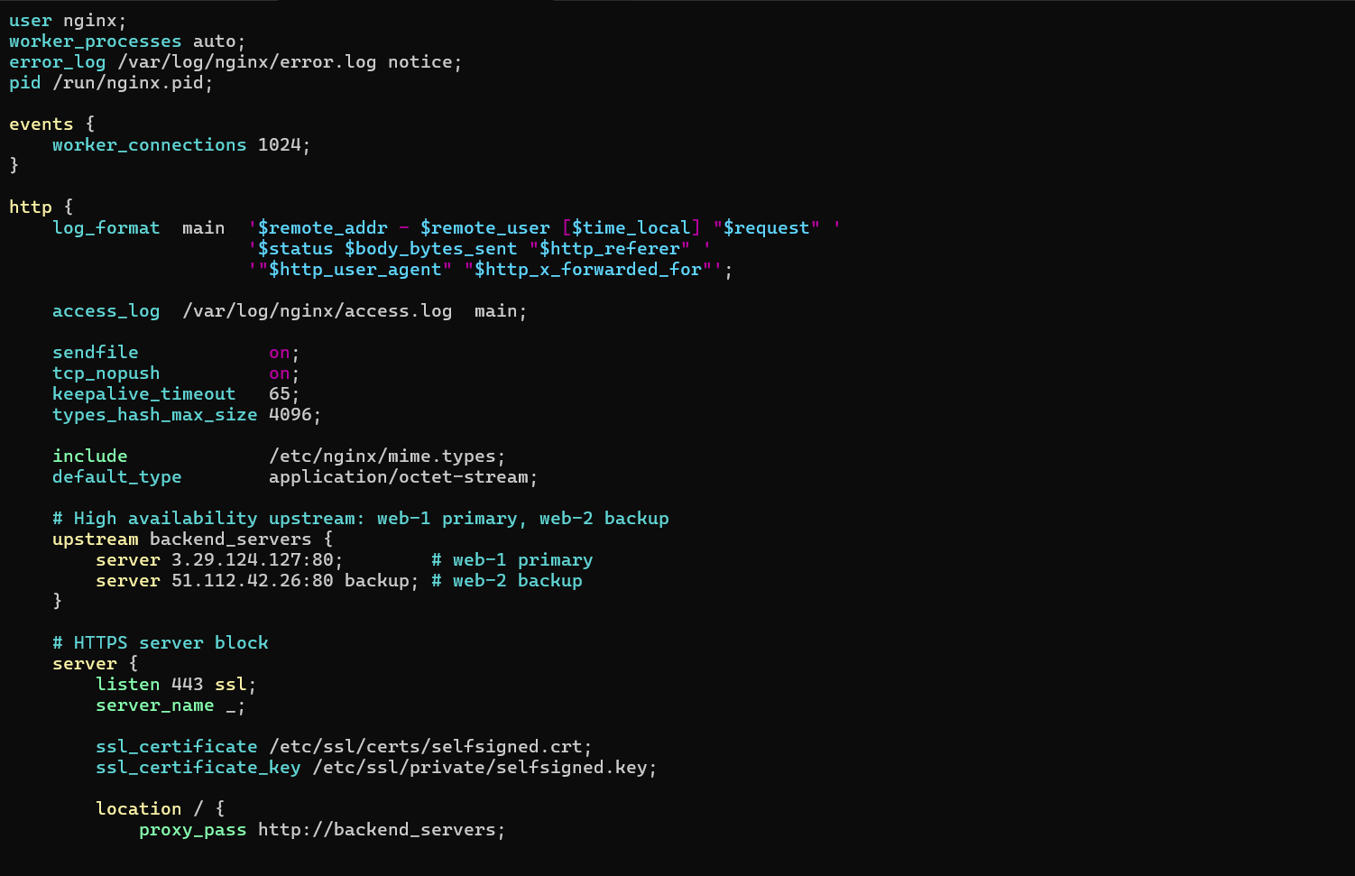
- task9_ha_web1_only.png

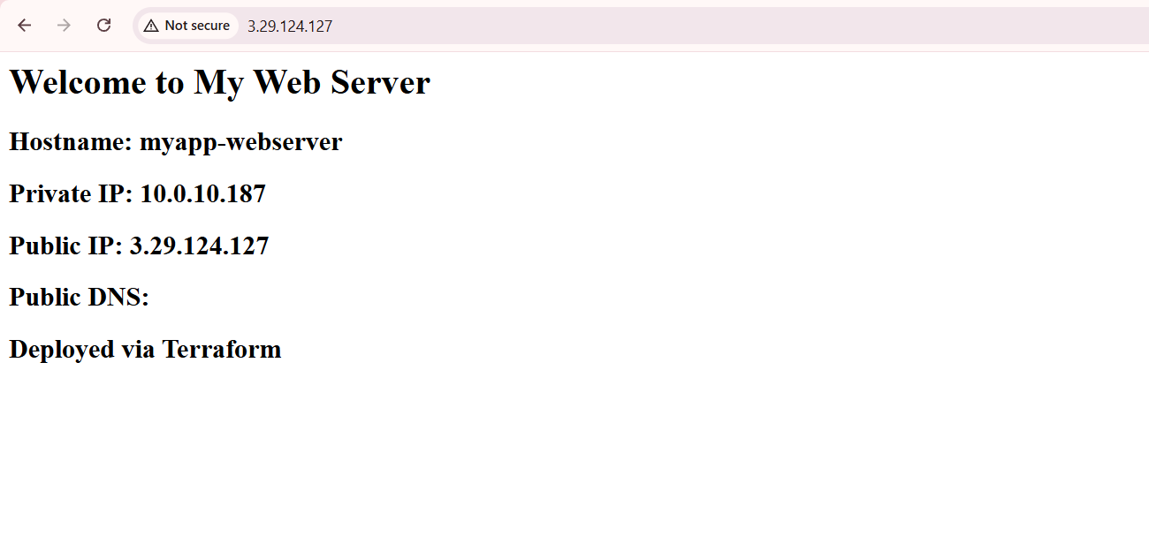
- task9_nginx_conf_ha_web2_primary.png
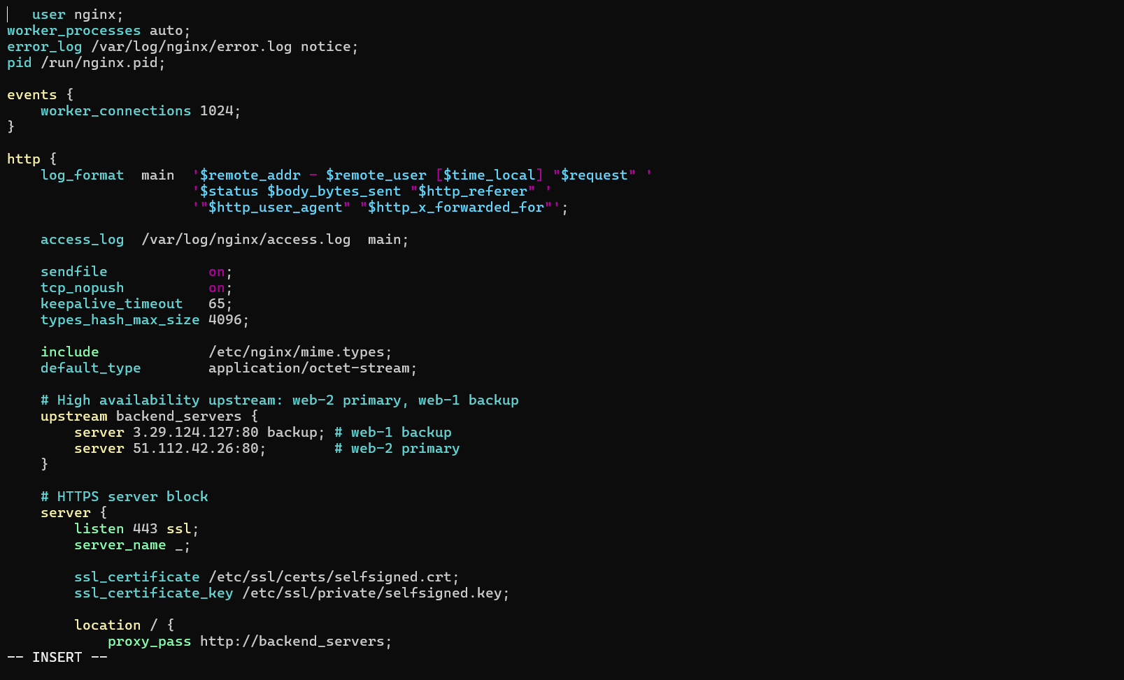
- task9_ha_web2_only.png
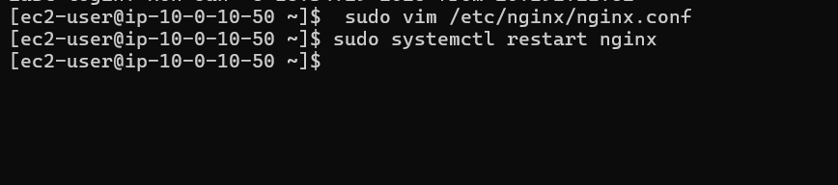
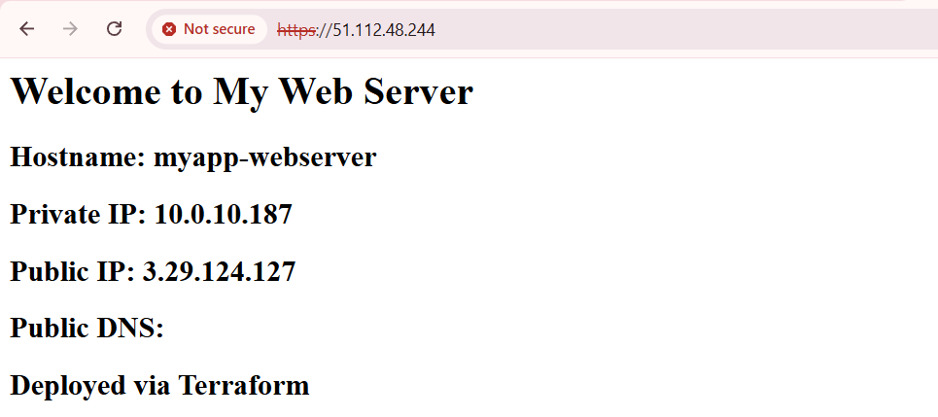
Task 10 — Enable Nginx caching
- task10_nginx_conf_cache.png
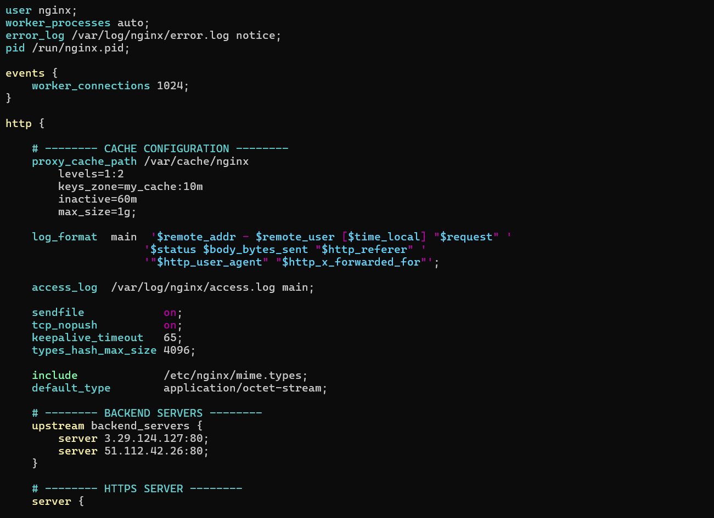
- task10_nginx_restart.png
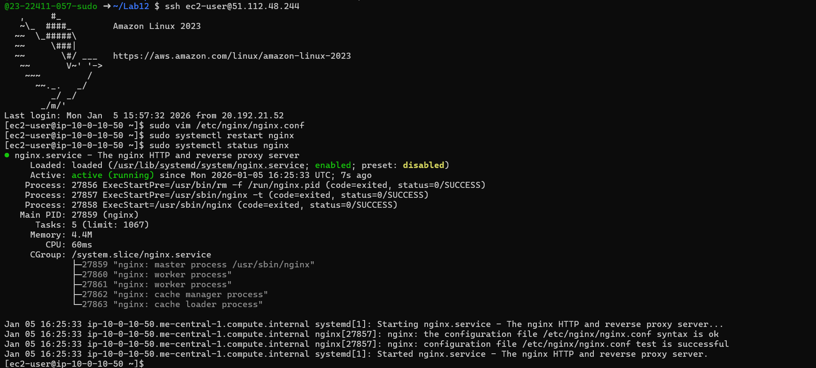
- task10_cache_miss.png
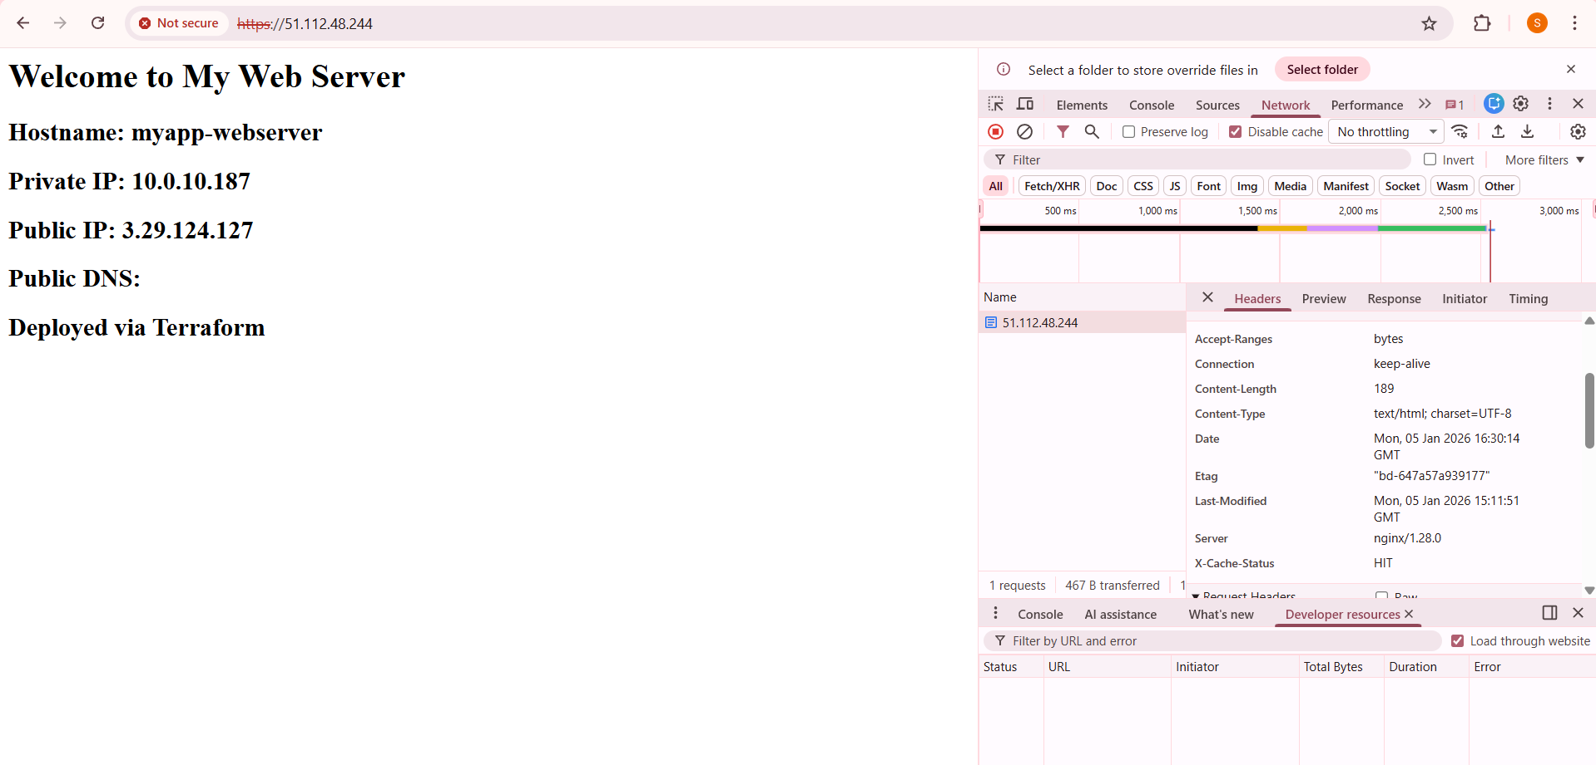
- task10_cache_hit.png
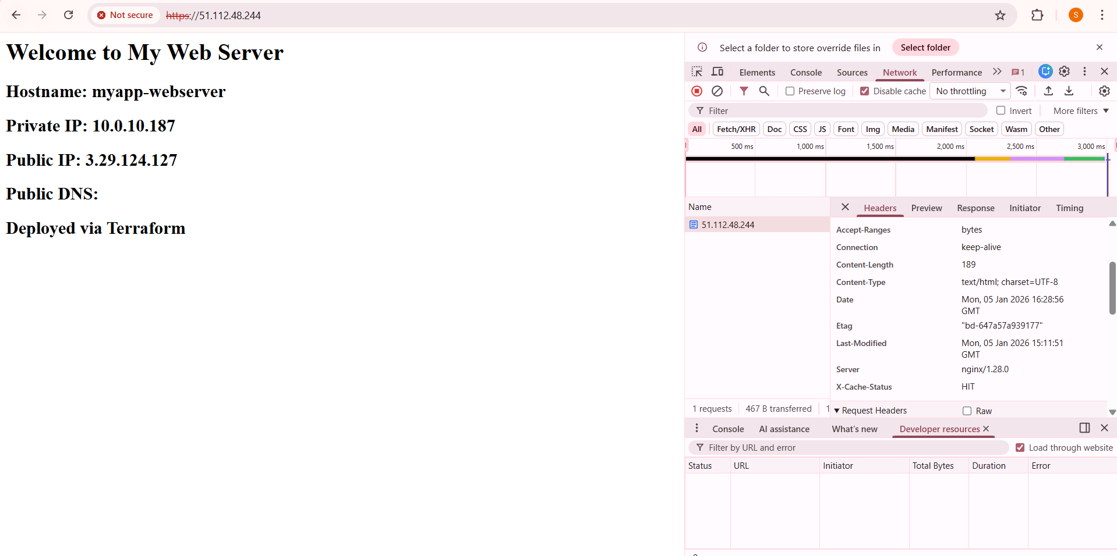
- task10_cache_directory.png
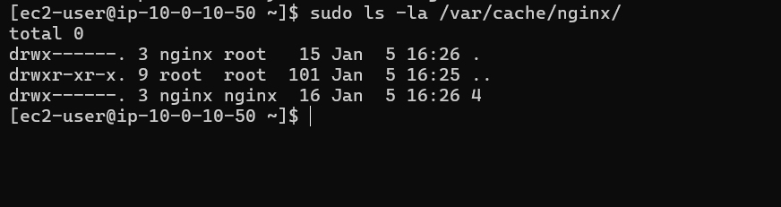
Cleanup
- cleanup_destroy_prompt.png
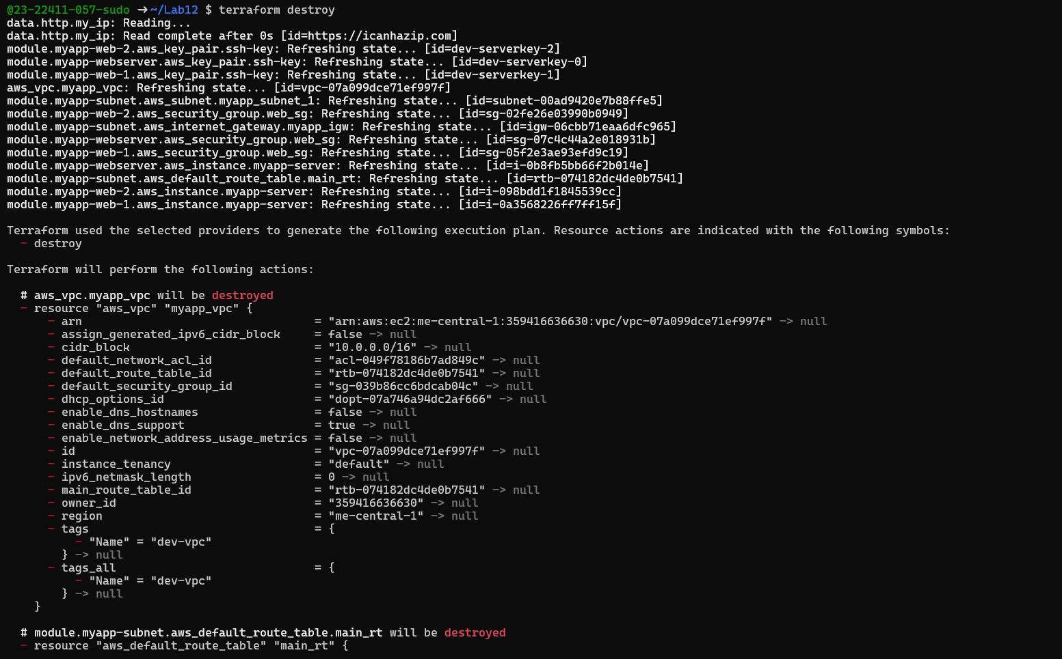
- cleanup_destroy_complete.png
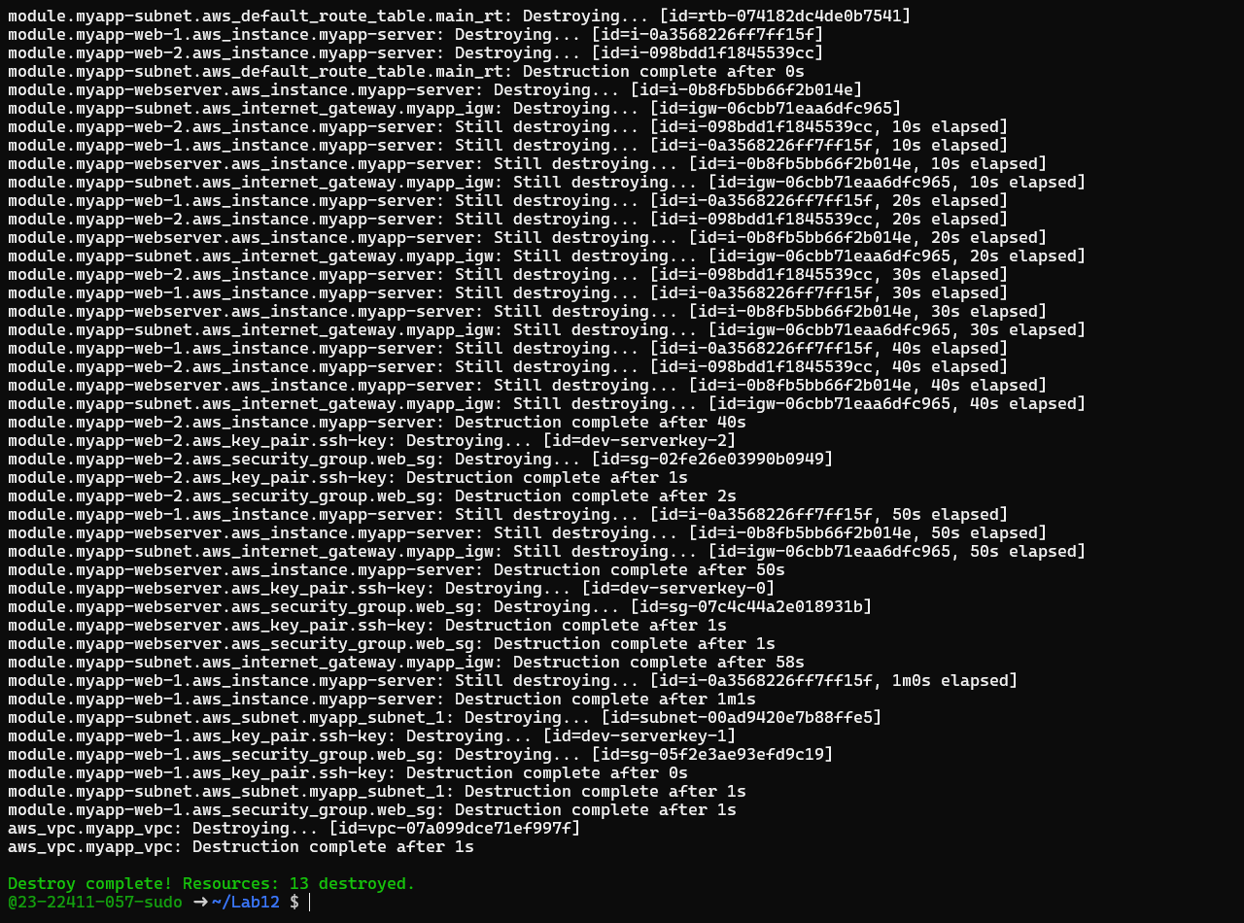
- cleanup_state_empty.png
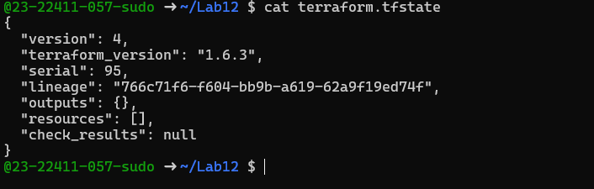
- cleanup_final_files.png
